INDUSTRIAL TRAINING
at

Somayu Infotech
Training | Development | Innovation
ON

Full-Stack Development with AI
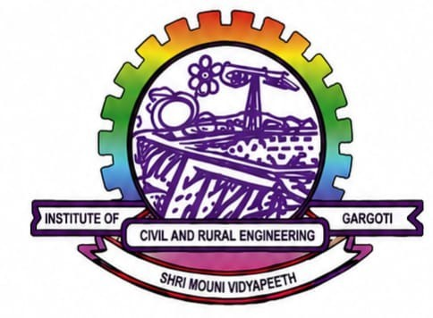
Submitted to
Shri Mouni Vidyapeeth’s

Government Polytechnic Awasari (Khurd).
Submitted by
Yash Vijay Date. Under the guidance of Mrs. Sangita Chavan Mam.
In Partial Fulfilment of
Diploma in Computer Engineering
(2026-27)



Maharashtra State Board of Technical Education

Certificate of Completion of Industrial Training
(By respective Head of the Department & Head of the Institute)

This is to certify that “Yash Vijay Date”, with Enrolment No 24210270230 has successfully completed his Industrial Training (315004) at “Somayu Infotech, Narayangaon” on “Full-Stack Development with AI” from 25/05/2026 to 23/08/2026 for partial fulfillment towards completion of Diploma in Computer Engineering from Government Polytechnic Awasari (Khurd). Government Polytechnic Awasari (Khurd).

Signature of
Head of Institute
Signature of Head of Department
Signature of
Internship Mentor
Signature of
Industry Mentor

ABSTRACT
I carried out my industrial training at “Somayu Infotech, Pune”, where I gained hands-on
experience in “Full-Stack Development with AI”. During the training, I learned and practiced
the following skills:
Frontend Development: HTML, CSS, and JavaScript for creating responsive and user-friendly web pages.
Backend & Database: Python for server-side programming and MySQL for database management.
AI Integration: Explored AI tools and APIs to understand and implement AI features within full-stack applications.
Practical Implementation: Developed multiple website clones to understand real-world
design structures, layouts, and functionality.
During the training period, a number of approaches, submissions, extra activities, presentation,
tasks regarding under the training facilitator of Mr. Yuvraj Hande Sir. The training is intended to develop the competencies like Communication, Presentation, Time Management, Innovation, Team Management, Design,
Implementation, etc. which are needed to be develop in every student. These activities helped me to interact with different people, team members which helps me to get more knowledge and experience.

ACKNOWLEDGMENT
I would like to express my deep and sincere gratitude to my Guide Mrs. Sangita Chavan Mam Department of Computer Engineering, for guiding me to accomplish this Industrial Training.

I express my deep gratitude to Mrs. Megha Yawalkar Mam Head of Computer Engineering Department, for her valuable guidance and constant encouragement. I am very much thankful to Mr. Vitthal Bandal Sir Principal, Government Polytechnic Awasari (Khurd). I would also like to thank Somayu Infotech, Pune, for allowing me to undergo the Industrial Training at their company.

Mr. Yuvraj Hande Sir (Somayu Infotech) and Mrs. Sangita Chavan Mam (College Mentor) are acknowledged for providing the information and help during Training period. Last but not least, it would not have possible for me to complete the training without support of my family members. Constant encouragement and support of my Father and Mother made me possible to complete the work.

Sincerely

CONTENTS
Sr. No. | Content Name | Page No.
1. | Certificate of Completion
2. | Abstract
3. | Acknowledgement
4. | Table of Contents
5. | Chapter 1: Company Profile – Somayu Infotech, Pune
6. | Chapter 2: Introduction to Full-Stack Development with AI
7. | Chapter 3: Technologies Used
8. | Chapter 4: Training Schedule and Learning Activities
9. | Chapter 5: Practical Tasks and Assignments
10. | Chapter 6: Project Development
11. | Chapter 7: AI Tools Used in Development
12. | Chapter 8: Skills Acquired During Training
13. | Chapter 9: Challenges Faced and Solutions
14. | Chapter 10: Conclusion and Future Scope
15. | References
16. | Appendix (Screenshots, Certificates & Project Outputs)

COMPANY PROFILE

Name of Industry
Somayu Infotech, Pune

About Somayu Infotech
Somayu Infotech is a leading IT training and software development company located in Pune, Maharashtra. The organization is dedicated to providing high-quality industry-oriented training programs, software development services, and innovative technology solutions. It aims to bridge the gap between academic education and industry requirements through practical learning and project-based training methodologies.
The company offers industrial training in modern technologies including Full-Stack Web Development, Artificial Intelligence (AI), Machine Learning, Data Analytics, Cloud Computing, and Software Engineering. Students gain hands-on experience by working on real-time projects under the guidance of experienced professionals. This approach enhances technical knowledge, teamwork, problem-solving skills, and industry readiness.
Somayu Infotech is committed to producing competent professionals capable of meeting the evolving demands of the IT industry while promoting innovation, technical excellence, and continuous learning.

Facilities
The major facilities and services offered by Somayu Infotech include:
- Full-Stack Web Development Training
- Artificial Intelligence (AI) Training
- Python Programming
- HTML, CSS, JavaScript, React.js & Node.js
- Database Management using MySQL and MongoDB
- REST API Development
- Git & GitHub Version Control
- Real-Time Industrial Projects
- Internship and Placement Assistance
- Software Development and IT Consulting
- Technical Workshops and Seminars

General Layout of Company
Company Name: Somayu Infotech
TRAINING | DEVELOPMENT | INNOVATION

INTRODUCTION TO FULL-STACK DEVELOPMENT WITH AI

Introduction
Full-Stack Development with Artificial Intelligence (AI) is an advanced approach to developing complete web applications by combining front-end, back-end, database management, deployment, and AI technologies. It enables developers to create intelligent, scalable, and user-friendly applications capable of solving real-world business problems through automation and data-driven decision-making.
During my industrial training at Somayu Infotech, Pune, I gained practical knowledge of developing full-stack web applications while integrating AI-powered features to improve application performance, functionality, and user experience. The training focused on modern development practices, real-time project implementation, and industry-standard tools and technologies.

What is Full-Stack Development?
Full-Stack Development refers to the development of both the client-side (front-end) and server-side (back-end) components of a web application. A Full-Stack Developer is responsible for designing, developing, testing, deploying, and maintaining complete web applications. This includes working with databases, APIs, version control systems, cloud platforms, and user interfaces.
A Full-Stack application consists of the following major components:

    - Front-End Development
The front-end is responsible for the user interface and user experience of a web application. It is developed using technologies such as:
      - HTML5
      - CSS3
      - JavaScript
      - React.js

    - Back-End Development
The back-end handles server-side logic, business processes, authentication, and communication with databases. Common technologies include:
      - Node.js
      - Express.js
      - Python

    - Database Management
Databases are used to store, retrieve, and manage application data efficiently. Popular database technologies include:
      - MySQL
      - MongoDB

    - Deployment
Deployment involves hosting and maintaining applications on cloud platforms or web servers, ensuring availability, scalability, and security.

What is AI in Full-Stack Development?
Artificial Intelligence (AI) enhances web applications by enabling them to analyze data, learn from user interactions, automate repetitive tasks, and make intelligent decisions. AI integration makes applications more efficient, personalized, and capable of providing better user experiences.
AI can be incorporated into Full-Stack applications through various technologies and techniques, including:
- Machine Learning (ML)
- Natural Language Processing (NLP)
- AI Chatbots
- Recommendation Systems
- Predictive Analytics
- Image and Text Processing
By integrating AI capabilities, web applications become smarter, faster, and more user-centric, enabling businesses to automate workflows and improve productivity.

Importance of Full-Stack Development with AI
The integration of Full-Stack Development with Artificial Intelligence offers several advantages in today's software industry:
    - Provides complete end-to-end web development skills.
    - Enables the development of scalable, secure, and efficient applications.
    - Improves automation and intelligent decision-making.
    - Enhances user experience through AI-powered features.
    - Reduces manual effort and increases operational efficiency.
    - Increases employability and career opportunities in the IT industry.
    - Supports the development of innovative and data-driven software solutions.

Objectives of Training
The primary objectives of this industrial training were:
- To understand the fundamentals of Full-Stack Web Development.
- To learn modern front-end and back-end technologies.
- To understand database design and management using MySQL and MongoDB.
- To develop and consume RESTful APIs.
- To integrate AI models into web applications.
- To gain practical experience through real-time industrial projects.
- To improve problem-solving, analytical thinking, and teamwork skills.
- To become familiar with Git and GitHub for version control.
- To understand application deployment and cloud hosting concepts.
- To prepare for a professional career in Full-Stack Development with AI.

TECHNOLOGIES USED

Introduction
During my industrial training at Somayu Infotech, Pune, I gained practical experience in developing modern full-stack web applications using various programming languages, frameworks, databases, development tools, and Artificial Intelligence (AI) technologies. The training emphasized industry-standard development practices, RESTful API development, responsive web design, version control, and AI integration for building intelligent applications.
The technologies used during the training are categorized as follows.

Front-End Technologies
Front-end technologies are responsible for designing and developing the user interface (UI) of web applications. These technologies ensure responsive layouts, interactive components, and an enhanced user experience.

Sr.
No.

Technology Description Purpose

- HTML5 Standard markup language for creating web page structures.
Defines page content and layout.

- CSS3 Style sheet language used for designing Improves appearance and
web pages. responsiveness.
- JavaScript Client-side scripting language. Adds dynamic functionality and
interactivity.

- React.js JavaScript library for building user
interfaces.
Develops fast and reusable UI components.

- Bootstrap CSS framework. Creates responsive and mobile-friendly designs quickly.

Back-End Technologies
Back-end technologies manage server-side operations, business logic, authentication, and communication with databases.

Sr.
No.

Technology Description Purpose

- Node.js JavaScript runtime environment. Develops scalable server-side
applications.

Sr.
No.
Technology Description Purpose

- Express.js Web application framework for Node.js.
Builds RESTful APIs and backend services.

- Python High-level programming language. AI/ML integration and backend
development.
- Flask Lightweight Python framework. Develops APIs and AI-enabled web
applications.

Database Technologies
Databases are used for storing, retrieving, updating, and managing application data efficiently.

Sr.
No.
Technology Description Purpose

- MySQL Relational Database Management System
(RDBMS).
Stores structured data using SQL.

- MongoDB NoSQL Database. Stores JSON-based and unstructured data.

Artificial Intelligence Technologies
Artificial Intelligence technologies were used to integrate intelligent features into web applications.

Sr.
No.
Technology Description Purpose

- OpenAI API AI API for natural language
processing.
Chatbots, content generation, automation.

- Google Gemini API
Google's Generative AI model. AI assistants, document analysis,
content generation.

- Prompt Engineering
Designing effective prompts for AI models.
Improves AI response quality and accuracy.

Development Tools
Development tools help in writing, testing, debugging, deploying, and managing software projects.

Sr.
No.
Tool Description Purpose

- Visual Studio Code
Source code editor. Writing and managing project code.

- Git Distributed Version Control System.
Tracks source code changes.

Sr.
No.
Tool Description Purpose
Code collaboration and version management.
3  4 | GitHub  Postman | Cloud-based repository platform.  API testing platform.
5 | npm | Node Package Manager.
6 | Figma | UI/UX Design Tool.

Testing and debugging REST APIs.
Installing and managing project dependencies.
Designing wireframes and application interfaces.

Deployment and Hosting Technologies
Deployment technologies were used to host applications and make them accessible over the internet.
Sr. No. Technology Description Purpose
- Netlify Cloud hosting platform. Deploys React front-end applications.
- Render / Railway Cloud hosting services. Hosts backend Node.js applications.
- GitHub Pages Static website hosting. Publishes portfolio and static websites.

Summary of Technologies Used
Category Technologies
Front-End HTML5, CSS3, JavaScript, React.js, Bootstrap Back-End Node.js, Express.js, Python, Flask
Database MySQL, MongoDB
AI Technologies OpenAI API, Google Gemini API, Prompt Engineering Development Tools VS Code, Git, GitHub, Postman, npm, Figma Deployment Netlify, Render/Railway, GitHub Pages

TRAINING SCHEDULE AND LEARNING ACTIVITIES

Introduction
The industrial training at Somayu Infotech, Pune was carefully planned to provide a balanced combination of theoretical knowledge and practical implementation. The training was conducted over a period of twelve weeks, during which various modern web development technologies, databases, APIs, Artificial Intelligence concepts, and real-time project development were covered. The training emphasized hands-on learning through coding exercises, mini-projects, workshops, and collaborative activities to strengthen both technical and professional skills.

Weekly Training Schedule
The following table summarizes the topics covered and activities performed during each week of the training.
Week Topics Covered Activities Performed
    - Learned the fundamentals of HTML, CSS, and JavaScript.

Week 1 HTML5, CSS3, JavaScript Fundamentals

Week 2 React.js and Front-End Development

Week 3 Node.js, Express.js and REST APIs

Week 4 Database Management (MySQL & MongoDB)
- Created responsive web pages.
- Practiced basic programming exercises and mini assignments.
- Understood website structure and styling concepts.
- Learned React components, JSX, Props, and State.
- Developed interactive user interfaces.
- Implemented event handling and forms.
- Built mini React applications.
- Understood server-side development using Node.js.
- Created RESTful APIs using Express.js.
- Connected frontend with backend APIs.
- Tested APIs using Postman.
- Learned SQL queries and database relationships.
- Performed CRUD operations.
- Connected databases with backend applications.
- Implemented data validation and storage techniques.

Week 5 Artificial Intelligence and Python • Learned Python fundamentals for AI
development.

Week Topics Covered Activities Performed
  - Explored Machine Learning and AI concepts.
  - Integrated AI APIs (OpenAI/Gemini) into web applications.
  - Worked on chatbot and text-generation features.
  - Developed a complete Full-Stack project.

Week 6 Full-Stack Project Development & Deployment
- Performed testing and debugging.
- Used Git and GitHub for version control.
- Deployed the application on cloud platforms.

Learning Activities
Throughout the training period, several practical learning activities were conducted to enhance technical knowledge and industry readiness.
Activity Description

Practical Coding Sessions
Daily coding practice to strengthen programming concepts and improve logical thinking.

Hands-on Exercises Solved practical problems related to front-end, back-end, and database development.
Mini Projects Developed small projects after completion of each technology module.

Real-Time Industrial Project
API Development & Testing
Worked on an industry-oriented Full-Stack application with AI integration.
Designed, developed, and tested REST APIs using Express.js and Postman.

Code Reviews Received mentor feedback to improve coding standards and best practices.
Workshops & Seminars Participated in technical sessions on modern web technologies and AI tools.
Self-Learning Explored documentation, online resources, and new technologies independently.
Group Discussions Collaborated with peers to solve technical challenges and share knowledge.
Problem Solving Improved analytical and debugging skills through regular assignments and project work.

Practical Exposure
During the industrial training, I gained practical exposure in the following areas:
    - Responsive Web Design using HTML5, CSS3, Bootstrap, and React.js.
    - Backend Development using Node.js and Express.js.
    - Database Management using MySQL and MongoDB.
    - REST API Development and Integration.

    - Git and GitHub for Version Control.
    - AI Integration using OpenAI and Gemini APIs.
    - Full-Stack Application Development.
    - Project Deployment on Cloud Platforms.
    - Debugging, Testing, and Performance Optimization.

Skills Acquired During Training
The training helped me develop the following technical and professional skills:
Technical Skills Professional Skills HTML5, CSS3, JavaScript Communication Skills React.js Teamwork
Node.js & Express.js Time Management MySQL & MongoDB Problem Solving REST API Development Critical Thinking Git & GitHub Adaptability
AI Integration Presentation Skills Project Deployment Self-Learning

Outcome of the Training
The twelve-week industrial training at Somayu Infotech, Pune significantly enhanced my knowledge of Full-Stack Development with Artificial Intelligence. The structured learning approach enabled me to understand modern web technologies, database management, backend development, API integration, and AI-powered application development. Working on real-time projects improved my practical coding skills, debugging abilities, teamwork, and problem-solving capabilities.
The training also provided valuable exposure to industry-standard development practices, version control systems, cloud deployment, and software development methodologies. Overall, the training built a strong technical foundation and increased my confidence in developing scalable, intelligent, and user-friendly web applications.

PRACTICAL TASKS AND ASSIGNMENTS

Introduction
During the industrial training at Somayu Infotech, Pune, I was assigned various practical tasks and project-based assignments to strengthen my understanding of Full-Stack Web Development, Artificial Intelligence (AI), Python API Development, and Business Intelligence using Power BI. The training emphasized hands-on learning, allowing me to apply theoretical concepts to real-world software development scenarios.
The practical tasks involved designing responsive user interfaces, developing server-side applications, creating RESTful APIs, managing relational databases, integrating AI services, developing Python APIs, creating Power BI dashboards, and deploying applications on cloud platforms. These activities significantly enhanced my technical knowledge, analytical thinking, debugging skills, and overall software development capabilities.

Practical Tasks Performed
The following practical tasks were completed during the industrial training program.

Sr.
No.
Practical Task Objective Technologies Used

- Website Development Learn webpage structure and styling HTML5, CSS3
- Responsive Website Design Create responsive layouts Bootstrap, CSS3
- JavaScript Form Validation Validate user inputs dynamically JavaScript
- Calculator Application Practice DOM manipulation and events JavaScript

- To-Do List Application Understand React components and
state
React.js

- REST API Development Develop backend services Node.js, Express.js

- CRUD Operations Perform Create, Read, Update and
Delete operations
- AI Chatbot Integration Integrate AI features into web
applications
MySQL
OpenAI API / Gemini API

- Python REST API Development
Build REST APIs using Python Python, Flask

- Power BI Dashboard Development
Develop interactive dashboards and reports
Power BI, SQL

- Full-Stack Project Deploy applications on cloud platforms Netlify

Sr.
No.
Practical Task Objective Technologies Used
Deployment

Assignments Completed
Throughout the training, several assignments were completed to improve programming skills, application development knowledge, and practical implementation abilities.

Sr.
No.

Assignment Description Technologies Used

- Portfolio Website Developed a professional personal
portfolio website.
HTML, CSS,
JavaScript

- Blog Management System
Developed a blog website with authentication.
React.js, Node.js, MySQL

- E-Commerce Website Designed a responsive online shopping
interface.
React.js, Bootstrap

- Feedback Management System
Created a feedback collection and management application.
Node.js, Express.js, MySQL

- AI Chatbot Application Integrated AI chatbot using
OpenAI/Gemini APIs.
React.js, OpenAI API

- Python API Project Developed REST APIs for data processing Python, Flask
and integration.
- Power BI Dashboard Built interactive dashboards with KPIs and Power BI, SQL
business reports.

Skills Acquired During Practical Training
The practical tasks and assignments helped in developing various technical and professional skills.
Category Skills Acquired
Front-End Development HTML5, CSS3, Bootstrap, JavaScript, React.js Back-End Development Node.js, Express.js
Database Management MySQL
API Development REST API Development using Node.js and Python Python Programming Flask API, JSON APIs
Artificial Intelligence OpenAI API, Gemini API Integration
Data Analytics Power BI Dashboard Development, DAX, Power Query Version Control Git, GitHub
API Testing Postman
Deployment Netlify, Render
Soft Skills Teamwork, Communication, Problem Solving, Time Management

Learning Outcomes
The practical training and assignments enabled me to achieve the following learning outcomes:
    - Developed responsive and user-friendly web applications.
    - Gained practical experience in Full-Stack Web Development.
    - Learned REST API development using Node.js and Express.js.
    - Developed Python APIs using Flask API.
    - Performed CRUD operations using MySQL.
    - Integrated Artificial Intelligence APIs into web applications.
    - Created interactive business dashboards using Microsoft Power BI.
    - Learned data visualization, Power Query, and DAX functions.
    - Improved debugging and troubleshooting skills.
    - Understood software development best practices and SDLC.
    - Gained experience in cloud deployment of web applications.
    - Enhanced logical thinking, coding standards, and analytical skills.
    - Improved teamwork, communication, and project management skills.

Challenges Faced During Training
While completing the practical tasks, several technical challenges were encountered. These challenges enhanced my troubleshooting abilities and practical understanding of software development.
Challenge Solution
Responsive layout issues Used Bootstrap Grid System and CSS Media Queries. JavaScript validation errors Applied proper event handling and validation techniques.
API integration issues Tested APIs using Postman and implemented exception handling.

Database connectivity problems
Configured MySQL connections and optimized SQL queries.

React state management Used React Hooks (useState, useEffect) efficiently. Python API development Implemented Flask/FastAPI routing and JSON responses.
AI API integration Improved prompt engineering and implemented API error handling.
Power BI data modeling Used Power Query, relationships, DAX measures, and calculated
columns.
Deployment issues Configured environment variables and cloud hosting services
correctly.

Outcome
The practical tasks and assignments played a significant role in enhancing my technical expertise in Full-Stack Development, Python Programming, Artificial Intelligence, REST API Development, and Business Intelligence using Power BI.

The project-based learning approach helped me understand the complete software development lifecycle—from designing user interfaces and developing backend services to database management, AI integration, dashboard creation, testing, debugging, and cloud deployment.
Working on real-world applications improved my confidence in building scalable, secure, and user-friendly software solutions while strengthening my analytical thinking, teamwork, and problem-solving abilities.

PROJECT DEVELOPMENT

Introduction
As a part of my industrial training at Somayu Infotech, Pune, I developed a Full-Stack Web Application integrated with Artificial Intelligence (AI). The project provided practical exposure to designing, developing, testing, and deploying a real-world software application using modern web technologies. It also enabled me to apply the theoretical concepts learned during training to solve practical problems efficiently.
The project involved front-end development, back-end API development, database management, AI integration, authentication, dashboard implementation, and deployment. It strengthened my understanding of the complete Software Development Life Cycle (SDLC) and industry-standard development practices.

Project Details
Particular Description
Project Title College Sahayak — Full-Stack Academic Portal with AI
Organization Somayu Infotech, Pune Project Type Full-Stack Web Application Duration Industrial Training Project
Domain Education Technology (EdTech)
Development Model Agile Development Project Status Successfully Completed

Project Overview
The College Sahayak — Full-Stack Academic Portal with AI is a web-based application developed to help students improve their learning experience through Artificial Intelligence. The application provides AI-powered answers to academic questions, allows users to manage study notes, take quizzes, and monitor their learning progress.

The system includes secure authentication, an interactive dashboard, AI-powered chatbot functionality, notes management, quiz modules, and user profile management. The application is designed with a responsive interface to ensure accessibility across multiple devices.

Project Objectives
The major objectives of the project were:
    - To develop a complete Full-Stack web application.
    - To integrate Artificial Intelligence APIs into the application.
    - To provide AI-assisted learning support for students.
    - To implement secure user authentication and authorization.
    - To manage study materials and quizzes effectively.
    - To develop RESTful APIs for data communication.
    - To create a responsive and user-friendly interface.
    - To deploy the application on a cloud platform.

Technologies Used
Layer Technology Purpose

Front-End HTML5, CSS3, JavaScript, React.js,
Bootstrap
User Interface Development

Back-End Node.js, Express.js Server-side Development
Database MySQL Data Storage and Management
AI Integration OpenAI API / Google Gemini API AI Chatbot and Intelligent
Responses
Python API Flask / FastAPI AI Processing and Backend Services
Data Analytics Power BI Dashboard and Business Analytics
Version Control Git & GitHub Source Code Management
API Testing Postman REST API Testing
Development Tool Visual Studio Code Code Development
Deployment Netlify, Render Cloud Hosting

System Architecture
The project follows a three-tier architecture integrated with Artificial Intelligence.
USER
│
▼
Front-End (React.js)
│
REST API Requests
│
▼
Backend (Node.js + Express.js)
│ │
│ │
▼ ▼
MySQL Database Python API
│
▼ OpenAI / Gemini API
│
▼
AI Generated Response

Module Description
Module Description
User Authentication Registration, Login, Password Encryption Dashboard User profile and application overview
AI Chat Assistant AI-powered question answering system Notes Management Store, update and organize study notes
Quiz Management Online quiz with automatic score calculation REST API Module Communication between frontend and backend Python API Module AI processing and external API integration Power BI Dashboard Reports, KPIs, and learning analytics
Admin Module User and content management

Key Features
The project includes the following major features:
    - Secure User Registration and Login
    - Responsive User Interface
    - AI-powered Chat Assistant
    - Study Notes Management
    - Online Quiz Module
    - Dashboard with User Statistics

    - RESTful API Architecture
    - Python API Integration
    - Power BI Analytics Dashboard
    - Role-based Authentication
    - Cloud Deployment
    - AI-powered Content Generation

Database Design
The project uses MySQL as the backend database for storing application data.

Major Database Tables
Table Name Purpose
users Stores user information
notes Stores study notes
quizzes Quiz information quiz_questions Quiz questions quiz_results Student scores chat_history AI conversation history
user_activity User login and activity logs

API Integration
The application integrates several APIs to enhance functionality.
API Purpose
Node.js REST API Communication between frontend and backend Python REST API AI processing and data services
OpenAI API AI-generated responses Google Gemini API Alternative AI assistant Authentication API User login and authorization

Testing Performed
The project was tested at different stages to ensure reliability and performance.
Testing Type Purpose
Unit Testing Test individual modules
API Testing Verify REST APIs using Postman Functional Testing Validate application features

Testing Type Purpose
UI Testing Verify responsive user interface Integration Testing Test communication between modules Database Testing Validate CRUD operations

Challenges Faced
During project development, several challenges were encountered.
Challenge Solution
API Integration Errors Used Postman and implemented exception handling Database Connectivity Optimized MySQL queries and connection pooling React State Management Used React Hooks effectively
Authentication Issues Implemented JWT-based authentication
AI Response Handling Improved prompt engineering and error handling Python API Communication Used REST APIs for seamless integration Dashboard Reporting Connected Power BI with MySQL datasets Deployment Configured environment variables and cloud hosting

Project Outcome
The project was successfully developed and deployed. It provided practical exposure to the complete Full-Stack Development process, including frontend development, backend API creation, database management, AI integration, Python API development, and Power BI dashboard creation.
The project enhanced my understanding of software architecture, REST API development, authentication, AI integration, cloud deployment, and business intelligence reporting. It also improved my debugging, coding, teamwork, and project management skills.

LEARNING OUTCOMES AND SKILLS GAINED

Introduction
The industrial training at Somayu Infotech, Pune provided me with valuable technical knowledge, practical experience, and professional exposure in modern software development. Throughout the training period, I worked on real-time projects involving Full-Stack Web Development, Artificial Intelligence (AI), Python API Development, and Power BI Dashboard Development.
The training enabled me to understand industry-standard development practices, improve problem-solving abilities, and strengthen both technical and professional competencies. It also enhanced my confidence in developing scalable web applications and data-driven solutions.

Technical Skills Gained
The following table summarizes the major technical skills acquired during the industrial training.

Sr.
No.
Technical Skill Description

- HTML5, CSS3 &
JavaScript
Developed responsive and interactive web applications using modern web technologies.

- React.js Built reusable UI components using JSX, Props, State, Hooks, and
React Router.
- Node.js & Express.js Developed RESTful APIs and implemented server-side business
logic.
- MySQL Designed relational databases and performed CRUD operations
using SQL.
- Python Learned Python programming and developed REST APIs using
Flask/FastAPI.
- Artificial Intelligence Integrated OpenAI API and Google Gemini API into web
applications.

- REST API
Development
Created, tested, and consumed REST APIs using Express.js and Python.

- Power BI Developed interactive dashboards, reports, KPIs, Power Query
transformations, and DAX measures.

Sr.
No.
Technical Skill Description

- Git & GitHub Managed source code using version control and collaborative
workflows.
- Postman & VS Code Tested APIs and developed applications using professional
development tools.

Professional Skills Gained
In addition to technical knowledge, the industrial training helped me improve various professional and interpersonal skills.
Professional Skill Description
Problem Solving Improved logical thinking and analytical abilities while solving real-world problems.
Team Collaboration Worked effectively with mentors and team members on development tasks.

Communication Skills
Enhanced verbal and written communication during project discussions and presentations.

Time Management Completed assignments and projects within scheduled timelines. Adaptability Learned and adopted new technologies quickly.
Critical Thinking Analyzed problems and identified efficient technical solutions. Attention to Detail Improved code quality through testing and debugging.
Self-Learning Explored documentation and learned new frameworks independently.

Key Learnings
The industrial training provided practical exposure to various aspects of software development. The major learning outcomes include:
    - Understood the complete Software Development Life Cycle (SDLC).
    - Developed responsive web applications using React.js.
    - Built RESTful APIs using Node.js, Express.js, and Python.
    - Designed and managed relational databases using MySQL.
    - Integrated Artificial Intelligence APIs into Full-Stack applications.
    - Created business intelligence dashboards using Microsoft Power BI.
    - Learned API testing using Postman.
    - Used Git and GitHub for version control and collaborative development.
    - Understood project deployment on cloud platforms.
    - Improved debugging, testing, and software maintenance skills.
    - Learned clean coding standards and modular application development.
    - Gained practical exposure to industry-oriented software development methodologies.

Skills Matrix
Category Technologies / Skills
Front-End Development HTML5, CSS3, JavaScript, Bootstrap, React.js Back-End Development Node.js, Express.js
Database MySQL Programming Languages JavaScript, Python
AI Technologies OpenAI API, Google Gemini API API Development REST API, Flask
Business Intelligence Microsoft Power BI, Power Query Version Control Git, GitHub
Testing Tools Postman Development Tools Visual Studio Code Deployment Netlify, Render

Overall Outcome
The industrial training significantly enhanced my technical knowledge and practical software development skills. It helped me bridge the gap between academic learning and real-world implementation by providing hands-on experience in developing Full-Stack applications integrated with Artificial Intelligence and Business Intelligence solutions.
The training also strengthened my confidence in designing responsive user interfaces, developing backend services, creating RESTful APIs, integrating AI functionalities, developing Python APIs, managing databases, and building Power BI dashboards. Working on real-time projects improved my ability to solve complex technical problems while following industry-standard software development practices.

Career Readiness
After successfully completing the industrial training, I am confident in performing the following professional responsibilities:
    - Develop responsive Full-Stack web applications.
    - Design and develop RESTful APIs using Node.js and Python.
    - Manage relational databases using MySQL.
    - Integrate AI services using OpenAI and Gemini APIs.
    - Develop business intelligence dashboards using Microsoft Power BI.
    - Test and debug applications using Postman.
    - Manage projects using Git and GitHub.
    - Deploy applications on cloud platforms.
    - Work effectively in Agile software development environments.

    - Collaborate efficiently within software development teams.

CONCLUSION AND FUTURE SCOPE

Introduction
The industrial training at Somayu Infotech, Pune was a valuable learning experience that significantly enhanced my technical knowledge, practical skills, and professional confidence. During the training, I gained hands-on experience in Full-Stack Web Development, Artificial Intelligence (AI), Python API Development, MySQL Database Management, and Power BI Dashboard Development.
The exposure to real-time projects, modern development tools, and industry-standard practices helped me bridge the gap between academic learning and practical implementation. The training also improved my problem-solving abilities, teamwork, communication skills, and understanding of the complete software development life cycle.

Conclusion
The industrial training provided a strong foundation in modern software development and Artificial Intelligence. Throughout the training period, I successfully applied theoretical concepts to practical applications by developing responsive web applications, designing RESTful APIs, integrating AI services, developing Python APIs, and creating interactive Power BI dashboards.
Working on real-time projects helped me understand industry workflows, software architecture, database management, cloud deployment, debugging techniques, and version control systems. The guidance and continuous support provided by the mentors at Somayu Infotech, Pune played a crucial role in enhancing my technical competencies and professional growth.
The training has prepared me to confidently undertake software development projects and has strengthened my ability to work effectively in professional IT environments.

Knowledge and Skills Acquired
The following table summarizes the major knowledge and skills gained during the industrial training.
Area Knowledge Gained

Full-Stack Development
Front-End Development
Back-End Development
Database Management
Learned complete web application development using React.js, Node.js, Express.js, and MySQL.
Developed responsive user interfaces using HTML5, CSS3, JavaScript, Bootstrap, and React.js.
Built secure RESTful APIs and implemented server-side business logic.
Designed relational databases and performed CRUD operations using MySQL.

Python Development Developed REST APIs using Flask/FastAPI and integrated backend services.
Artificial Intelligence Integrated OpenAI and Google Gemini APIs into web applications.
Power BI Created dashboards, reports, KPIs, Power Query transformations, and DAX calculations.
API Testing Tested APIs using Postman.
Version Control Managed projects using Git and GitHub.
Cloud Deployment Deployed applications using Netlify and Render.

What I Learned
During the industrial training, I achieved the following learning outcomes:
    - Understood the complete Software Development Life Cycle (SDLC).
    - Developed responsive web applications using modern front-end technologies.
    - Learned server-side application development using Node.js and Express.js.
    - Developed REST APIs using both Node.js and Python.
    - Designed and managed relational databases using MySQL.
    - Integrated Artificial Intelligence APIs into Full-Stack applications.
    - Built interactive business intelligence dashboards using Microsoft Power BI.
    - Improved debugging, testing, and API integration skills.
    - Learned software version control using Git and GitHub.
    - Understood cloud deployment and application hosting.
    - Enhanced problem-solving, logical thinking, and analytical skills.
    - Worked on real-time industrial projects and assignments.

Future Scope
The field of Full-Stack Development with Artificial Intelligence and Business Intelligence offers tremendous career opportunities. In the future, I plan to enhance my expertise in advanced technologies and contribute to innovative software solutions.
Area Future Plan

Artificial Intelligence & Machine Learning
Learn advanced AI/ML algorithms and develop intelligent applications.

Cloud Computing Gain expertise in AWS, Microsoft Azure, and Google Cloud
Platform for scalable deployments.
Python Development Develop enterprise-level APIs and automation solutions using
Python.
Business Intelligence Master advanced Power BI features, DAX, Power Query, and data
modeling.

Mobile Application Development
Learn React Native and Flutter for cross-platform mobile applications.

DevOps Learn Docker, Kubernetes, Jenkins, and CI/CD pipelines. Cyber Security Understand secure coding practices and application security.
Career Development Work as a Full-Stack Developer, Python Developer, AI Engineer,
or Power BI Developer.

Professional Development
The industrial training has also contributed significantly to my professional growth by improving the following competencies:
Professional Skill Improvement Achieved

Communication Skills
Improved interaction with mentors and team members.

Teamwork Collaborated effectively on project development activities. Time Management Completed assignments and projects within deadlines.
Problem Solving Developed logical and analytical thinking. Adaptability Learned and implemented new technologies quickly. Leadership Took initiative during project development activities.
Self-Learning Enhanced the ability to learn independently using documentation and online resources.

Final Thoughts
The industrial training at Somayu Infotech, Pune has been one of the most valuable milestones in my academic and professional journey. It provided practical exposure to industry-standard technologies and helped me understand the real-world software development process.

The experience gained through Full-Stack Development, Python API Development, Artificial Intelligence integration, MySQL database management, and Power BI dashboard creation has significantly improved my confidence and technical expertise. The knowledge acquired during this training will serve as a strong foundation for my future career in the Information Technology industry.
I am grateful to the management, mentors, and entire team of Somayu Infotech for their continuous guidance, encouragement, and support throughout the training period.

ACKNOWLEDGEMENT

Introduction
I would like to express my sincere gratitude to everyone who supported, guided, and encouraged me throughout my industrial training at Somayu Infotech, Pune. The training provided me with an excellent opportunity to enhance my technical knowledge, practical skills, and professional confidence in the fields of Full-Stack Web Development, Artificial Intelligence, Python API Development, and Power BI.
The continuous guidance, valuable suggestions, and encouragement received from my mentors and colleagues played a significant role in the successful completion of my industrial training and project work.

Acknowledgement
I express my heartfelt gratitude to the management of Somayu Infotech, Pune, for providing me with the opportunity to undergo industrial training in a professional and innovative learning environment.
I sincerely thank Mr. Somayu Shinde (Founder) for giving me the opportunity to be a part of the organization and for his constant motivation, encouragement, and valuable support throughout the training period.
I would also like to extend my sincere appreciation to my mentors, trainers, and the development team for sharing their technical expertise, guiding me in project development, and helping me understand industry-standard software development practices.
Their valuable suggestions, practical demonstrations, and continuous support greatly contributed to improving my technical knowledge in React.js, Node.js, Express.js, MySQL, Python, Artificial Intelligence APIs, REST API Development, Git & GitHub, Power BI, and Cloud Deployment.

Grateful To
The following individuals and teams contributed significantly to my learning journey.
Person / Team Contribution

Mr. Somayu Shinde (Founder)
Provided me with the opportunity to undergo industrial training and continuously motivated me throughout the learning journey.

Mentors and Trainers Guided me in Full-Stack Development, Artificial Intelligence, Python API Development, Power BI, and real-time project implementation.
Development Team Shared industry experience and provided technical assistance during project development.

Quality Assurance Team
Friends and Colleagues
Assisted in software testing, debugging, and quality improvement.
Encouraged teamwork, collaboration, and knowledge sharing throughout the training.

My Family Offered continuous support, motivation, and encouragement during the entire training period.

Special Thanks
I would like to express my special thanks to the entire team of Somayu Infotech, Pune, for creating an excellent learning environment that encouraged innovation, creativity, and continuous learning.
The practical exposure to modern technologies, real-time industrial projects, and professional software development practices has significantly enhanced my technical expertise, analytical thinking, and confidence.
The guidance and mentorship received during the training will always remain an important milestone in my academic and professional career.

Acknowledgement Statement
I hereby declare that this Industrial Training Report entitled:
"Full-Stack Web Development with Artificial Intelligence, Python API Development, and Power BI"
is a genuine record of the work carried out by me during the industrial training at Somayu Infotech, Pune, under the valuable guidance of my mentors and trainers.
The report has been prepared based on the knowledge gained, practical work completed, and real-time projects developed during the training period.

Learning Experience
The industrial training provided me with practical exposure to modern software development technologies and industry-standard development methodologies. During the training, I learned:
    - Full-Stack Web Development using React.js, Node.js, and Express.js.
    - Database design and management using MySQL.
    - REST API development and integration.
    - Python API development using Flask/FastAPI.
    - Artificial Intelligence integration using OpenAI and Google Gemini APIs.
    - Business Intelligence dashboard development using Microsoft Power BI.
    - Version control using Git and GitHub.
    - API testing using Postman.
    - Cloud deployment using Netlify and Render.
The knowledge gained through these activities has significantly improved my programming skills and practical understanding of software engineering concepts.

Closing Note
The industrial training at Somayu Infotech, Pune has been one of the most rewarding experiences of my academic journey. It has helped me develop not only technical expertise but also professional values such as teamwork, discipline, communication, responsibility, and continuous learning.
I sincerely thank everyone who directly or indirectly contributed to my successful completion of the industrial training. Their encouragement, guidance, and support have inspired me to continue learning and striving for excellence in the field of Information Technology.
I will always remain grateful to Somayu Infotech, its management, mentors, trainers, colleagues, and my family for their invaluable support throughout this learning journey.

REFERENCES AND BIBLIOGRAPHY

Introduction
During the industrial training at Somayu Infotech, Pune, and while preparing this industrial training report, I referred to various textbooks, official documentation, online tutorials, technical articles, and educational resources. These references helped me understand the concepts of Full-Stack Web Development, Python Programming, REST API Development, Artificial Intelligence (AI), Power BI, and Software Engineering. They also provided practical guidance for implementing real-world projects and solving technical challenges encountered during the training.

Books Referred
The following books were used as reference materials during the training and report preparation.

Sr.
No.
Book Name Author(s) Publisher

- HTML and CSS: Design and Build Jon Duckett Wiley Websites
- JavaScript: The Definitive Guide David Flanagan O'Reilly Media
- Learning React (2nd Edition) Alex Banks & Eve Porcello O'Reilly Media

- Node.js Design Patterns Mario Casciaro & Luciano
Mammino
- Database System Concepts Abraham Silberschatz, Henry F.
Korth & S. Sudarshan
Packt Publishing
McGraw-Hill Education

- Python Crash Course Eric Matthes No Starch Press

- Microsoft Power BI Data Analyst Certification Guide
Daniil Maslyuk Packt Publishing

Websites and Online Resources
The following official websites and online learning resources were frequently referred to during the industrial training.

Sr.
No.

Website / Resource Purpose

- MDN Web Docs (developer.mozilla.org) HTML, CSS, JavaScript, and Web APIs
documentation
- React Official Documentation (react.dev) Learning React.js concepts and best
practices
- Node.js Documentation (nodejs.org) Backend development and Node.js APIs
- Express.js Documentation (expressjs.com) REST API development using Express.js
- MySQL Documentation (dev.mysql.com/doc) Database management and SQL reference
- Python Documentation (python.org) Python programming language reference
- Flask Documentation (flask.palletsprojects.com) Python API development
- FastAPI Documentation (fastapi.tiangolo.com) Modern Python REST API framework

- Microsoft Learn - Power BI (learn.microsoft.com/power-bi)
- OpenAI API Documentation (platform.openai.com/docs)
Power BI dashboards, DAX, and Power Query
AI integration and API implementation

- Google AI Studio / Gemini Documentation Gemini AI API integration
- W3Schools (w3schools.com) Programming tutorials and examples
- Stack Overflow (stackoverflow.com) Technical problem solving and community
support
- GitHub Documentation (docs.github.com) Version control and repository
management

Software and Development Tools
The following software and development tools were used during the industrial training.
Software / Tool Purpose
Visual Studio Code Source code editor
Git Version control system
GitHub Source code hosting and collaboration
Postman REST API testing MySQL Workbench Database management
XAMPP Local development environment
Power BI Desktop Data visualization and dashboard development Node.js Backend runtime environment
npm Package management
Python Programming and API development

Other References
The following additional resources contributed to the successful completion of the industrial training.
    - YouTube Tutorials
      - Traversy Media
      - CodeWithHarry
      - Programming with Mosh
      - FreeCodeCamp
      - Web Dev Simplified
    - Online Learning Platforms
      - Coursera
      - Udemy
      - freeCodeCamp
      - Microsoft Learn
    - Official Documentation
      - Bootstrap Documentation
      - React Documentation
      - Node.js Documentation
      - Express.js Documentation
      - Python Documentation
      - Flask Documentation
      - Power BI Documentation
      - Git Documentation
      - Postman Documentation
    - Mentors and Trainers
      - Guidance and technical support received from mentors and trainers at Somayu Infotech, Pune.

APPENDICES

Introduction
This chapter contains supplementary documents, screenshots, certificates, and supporting materials related to the industrial training completed at Somayu Infotech, Pune. These appendices provide additional evidence of the practical work carried out during the training and support the concepts discussed throughout this report.
The appendix includes the training certificate, list of tools and technologies used, project screenshots, supporting documents, and a declaration regarding the authenticity of the work completed during the industrial training.

Industrial Training Certificate
The Industrial Training Certificate issued by Somayu Infotech, Pune certifies the successful completion of the training program in Full-Stack Web Development with Artificial Intelligence, Python API Development, and Power BI.
Certificate Details
Particular Information
Organization Somayu Infotech, Pune
Training Program Full-Stack Web Development with AI, Python API & Power BI Duration 25th May 2026 – 23rd August 2026
Candidate Name Yash Vijay Date
Status Successfully Completed
Note:
Attach the original Industrial Training Certificate in this section.

Tools and Technologies Used
The following technologies and software tools were used during the industrial training.
Category Tools / Technologies Purpose

Programming Languages
HTML5, CSS3, JavaScript, Python
Front-end development, scripting, and API development

Front-End React.js, Bootstrap Responsive User Interface Development
Back-End Node.js, Express.js REST API Development and Server-side
Programming
Database MySQL Data Storage and Management

Artificial Intelligence OpenAI API, Google Gemini API
AI-powered Chatbot and Intelligent Features

Business Intelligence Microsoft Power BI Dashboard, Reports, Data Visualization Development Tools Visual Studio Code Source Code Development
API Testing Postman REST API Testing
Version Control Git, GitHub Source Code Management
Deployment Netlify, Render Cloud Deployment

Project Screenshots
The following screenshots demonstrate the major modules of the developed project.
Module Description
Login Page User authentication with secure login. Registration Page New user registration and account creation.
Dashboard Displays application statistics and user information. AI Chat Assistant AI-powered chatbot using OpenAI/Gemini APIs.
Notes Management Create, update, and manage study notes. Quiz Module Online quiz with automatic score calculation.
User Profile Manage personal information and account settings. Power BI Dashboard Interactive reports, KPIs, charts, and analytics.
Python API Response Demonstrates Python REST API communication.
The following subsections showcase the actual user interfaces, dashboards, and operational screenshots of all three internship projects developed during the training.
Insert actual screenshots of each module in this section.

Additional Documents Attached
The following supporting documents are attached along with this industrial training report.
Sr. No. Document
- Industrial Training Offer Letter

Sr. No. Document
- Industrial Training Completion Certificate
- Attendance Record
- Weekly Progress Report
- Project Report Document
- Mentor Evaluation Form
- Student Feedback Form
- Project Source Code (if applicable)
- Power BI Dashboard Report
- Python API Documentation

Project Deliverables
The following deliverables were successfully completed during the industrial training.
Deliverable Status

Full-Stack Web Application REST API Development MySQL Database Design Python REST API
AI Integration (OpenAI/Gemini) Power BI Dashboard
Cloud Deployment Project Documentation
Final Industrial Training Report
✔ Completed
✔ Completed
✔ Completed
✔ Completed
✔ Completed
✔ Completed
✔ Completed
✔ Completed
✔ Completed

Declaration
I hereby declare that all the information, project work, screenshots, documents, and technical details presented in this Industrial Training Report are true and correct to the best of my knowledge.
The work presented in this report was carried out by me during my industrial training at Somayu Infotech, Pune, under the guidance of my mentors and trainers. All external references used in preparing this report have been properly acknowledged in the bibliography section.

PERSONAL REFLECTIONS

Introduction
The industrial training at Somayu Infotech, Pune has been one of the most valuable experiences of my academic journey. It provided me with an excellent opportunity to apply classroom knowledge to real-world software development projects while learning modern technologies such as Full-Stack Web Development, Artificial Intelligence (AI), Python API Development, and Microsoft Power BI.
The training not only enhanced my technical abilities but also helped me develop professional qualities such as teamwork, communication, discipline, responsibility, and continuous learning. This chapter presents my personal reflections on the overall training experience, the challenges I encountered, the lessons I learned, and how this training has prepared me for my future career.

My Learning Journey
The industrial training began with understanding the fundamentals of web development, including HTML, CSS, JavaScript, and responsive design. As the training progressed, I learned advanced front-end development using React.js, backend development using Node.js and Express.js, database management with MySQL, and REST API development.
Later, I explored Python programming for API development and integrated Artificial Intelligence using OpenAI and Google Gemini APIs. I also gained practical experience in creating interactive dashboards using Microsoft Power BI for business intelligence and data visualization.
Working on real-time projects gave me valuable exposure to software development practices, version control using Git and GitHub, API testing with Postman, debugging techniques, and cloud deployment. This gradual learning process significantly improved my confidence and technical proficiency.

My Growth Areas
The industrial training contributed to my overall growth in the following areas:
Growth Area Improvement Achieved
Programming Skills Improved coding proficiency in JavaScript and Python.

Full-Stack Development
Learned complete web application development using React.js, Node.js, Express.js, and MySQL.

Artificial Intelligence Successfully integrated AI APIs into web applications.

Python API Development
Developed REST APIs using Flask/FastAPI.

Power BI Created professional dashboards, reports, and data visualizations. Problem Solving Improved logical thinking and debugging abilities.
Teamwork Collaborated effectively with mentors and team members. Communication Skills Improved technical communication and presentation skills. Time Management Completed assignments and project milestones within deadlines.
Professional Ethics Understood industry standards, coding practices, and documentation.

Challenges Faced and How I Overcame Them
During the industrial training, I encountered several technical and practical challenges. These experiences helped me become a better learner and developer.
Challenge How I Overcame It Outcome

Learning New Technologies
Debugging Application Errors
Studied official documentation, watched tutorials, and practiced daily.
Used debugging tools, Postman, and mentor guidance to identify issues.
Quickly adapted to modern technologies.
Improved debugging and analytical skills.

API Integration Carefully studied API documentation and
implemented error handling.
Successfully integrated REST APIs and AI APIs.

Python API Development
Power BI Dashboard Design
Project Time Management
Practiced Flask/FastAPI through mini-projects and assignments.
Learned Power Query, DAX, and visualization techniques through practice.
Created weekly schedules and prioritized project tasks.
Developed functional Python REST APIs.
Built interactive dashboards and reports.
Completed the project within the training period.

Team Collaboration Maintained regular communication with
mentors and teammates.
Improved teamwork and project coordination.

Key Takeaways
The industrial training taught me several valuable lessons that will help me throughout my professional career.

    - Practical implementation is essential for understanding theoretical concepts.
    - Continuous practice improves programming and problem-solving skills.
    - Teamwork and communication are critical for successful software development.
    - Reading official documentation is one of the best ways to learn new technologies.
    - Debugging is an important part of the software development process.
    - Artificial Intelligence can significantly enhance modern web applications.
    - Python APIs simplify backend integration and automation.
    - Power BI enables effective business intelligence and data-driven decision-making.
    - Clean code, proper documentation, and version control improve project quality.
    - Continuous learning is the key to long-term success in the IT industry.

How This Training Will Help My Future Career
The industrial training has strengthened my technical foundation and increased my confidence in working on industry-level software projects.
The knowledge gained in React.js, Node.js, Express.js, MySQL, Python, REST API Development, Artificial Intelligence, and Power BI has prepared me for professional roles in software development and data analytics.
This training has also motivated me to continue learning advanced technologies such as Machine Learning, Cloud Computing, DevOps, and Mobile Application Development, enabling me to build innovative software solutions and contribute effectively to future projects.

Personal Reflection
Looking back on my industrial training, I realize that this experience has transformed me both technically and professionally. Initially, I had theoretical knowledge of software development concepts, but through continuous practice and real-time project implementation, I developed the confidence to build complete web applications independently.
The training taught me the importance of discipline, consistency, problem-solving, teamwork, and lifelong learning. I also realized that staying updated with emerging technologies is essential for building a successful career in the Information Technology industry.
Overall, this industrial training has been an important milestone in my learning journey and has inspired me to continuously improve my skills and knowledge.

SUMMARY AND OVERALL EVALUATION

Introduction
This chapter presents the overall summary and evaluation of the industrial training completed at Somayu Infotech, Pune. It highlights the knowledge acquired, technical and professional skills developed, practical exposure gained, and the overall impact of the training on my academic and career development.
The industrial training provided an excellent opportunity to gain practical experience in Full-Stack Web Development, Artificial Intelligence (AI), Python API Development, MySQL Database Management, REST API Development, and Microsoft Power BI through real-time projects and industry-oriented assignments.

Training Summary
The industrial training was successfully completed at Somayu Infotech, Pune, where I received practical exposure to modern software development technologies and industry-standard practices.
The training covered the complete software development process, including requirement analysis, UI development, backend programming, database design, REST API development, AI integration, Power BI dashboard creation, testing, debugging, and cloud deployment.
Working on real-time projects and assignments significantly improved my technical knowledge, practical implementation skills, logical thinking, teamwork, and professional confidence.

Training Overview
Particular Details
Organization Somayu Infotech, Pune
Training Domain Full-Stack Web Development with AI
Major Technologies React.js, Node.js, Express.js, MySQL, Python, Power BI Development Model Project-Based Learning
Training Type Industrial Training

Particular Details
Project College Sahayak — Full-Stack Academic Portal with AI
Status Successfully Completed

Skills Gained During Training
The following table summarizes the major skills acquired during the industrial training.
Category Skills Gained
Front-End Development HTML5, CSS3, JavaScript, Bootstrap, React.js Back-End Development Node.js, Express.js
Database Management MySQL, SQL Queries, CRUD Operations Python Development Flask/FastAPI, Python REST API Development Artificial Intelligence OpenAI API, Google Gemini API Integration
Business Intelligence Power BI, Power Query, DAX, Dashboard Development
API Development RESTful API Design and Integration
Version Control Git, GitHub
Testing Tools Postman, Browser Developer Tools Development Tools Visual Studio Code, npm, XAMPP Deployment Netlify, Render

Overall Evaluation
The industrial training greatly enhanced my technical abilities and practical software development skills. The following table presents the overall evaluation of my learning experience.
Evaluation Area Assessment Remarks
Technical Knowledge Excellent Developed strong understanding of Full-Stack
Development and AI.
Practical Exposure Excellent Successfully completed real-time projects and assignments.
Programming Skills Excellent Improved coding standards, debugging, and API
development.
Database Management Very Good Designed relational databases and performed CRUD
operations using MySQL.

Python API Development
Excellent Built REST APIs and integrated backend services.

Power BI Development Excellent Created dashboards, reports, KPIs, and data visualizations.

AI Integration | Excellent | Successfully integrated OpenAI and Gemini APIs into applications.
Teamwork | Excellent | Collaborated effectively with mentors and peers.
Communication Skills | Very Good | Improved technical communication and documentation.

Overall Learning Experience
Excellent Valuable industrial exposure and career-oriented learning.

Key Achievements
During the industrial training, I successfully accomplished the following milestones:
    - Developed a complete Full-Stack web application.
    - Built responsive web interfaces using React.js.
    - Developed RESTful APIs using Node.js and Express.js.
    - Created Python APIs using Flask/FastAPI.
    - Designed and managed MySQL databases.
    - Integrated OpenAI and Google Gemini APIs.
    - Developed interactive Power BI dashboards and reports.
    - Tested applications using Postman.
    - Used Git and GitHub for version control.
    - Deployed applications on cloud platforms.
    - Successfully completed the industrial training project.

Areas of Improvement
Although the training significantly enhanced my technical knowledge, I plan to further improve in the following areas:
Area Future Improvement Plan
Machine Learning Learn advanced ML algorithms and model deployment. Cloud Computing Gain expertise in AWS, Azure, and Google Cloud Platform. DevOps Learn Docker, Kubernetes, Jenkins, and CI/CD pipelines.
System Design Understand scalable software architecture. Mobile Development Learn React Native and Flutter.
Data Analytics Explore advanced Power BI features and data modeling. Cyber Security Learn secure coding and application security practices.

Overall Experience
The industrial training at Somayu Infotech, Pune has been an outstanding learning experience that has strengthened both my technical and professional capabilities. The opportunity to work on real-world projects enabled me to understand software development processes, project management, teamwork, and industry expectations.
The knowledge gained in Full-Stack Web Development, Python Programming, Artificial Intelligence, MySQL Database Management, REST API Development, and Microsoft Power

BI has increased my confidence in developing complete software solutions and prepared me for future challenges in the IT industry.

Final Remarks
The industrial training has played a significant role in shaping my career by providing practical exposure to industry-standard technologies and development methodologies. The experience gained during this training has enhanced my technical knowledge, analytical thinking, communication skills, and professional ethics.
I sincerely thank the management, mentors, trainers, and the entire team of Somayu Infotech, Pune for their continuous guidance, encouragement, and support throughout the training period.

FUTURE SCOPE AND RECOMMENDATIONS

Introduction
The industrial training at Somayu Infotech, Pune has provided me with a strong foundation in Full-Stack Web Development, Artificial Intelligence (AI), Python API Development, MySQL Database Management, REST API Development, and Microsoft Power BI. The knowledge and practical experience gained during this training have prepared me for future challenges in the software development industry.
This chapter presents the future scope of the technologies learned during the training, identifies areas for continuous improvement, and provides recommendations for enhancing future industrial training programs.

Future Scope
The demand for professionals skilled in Full-Stack Development, Artificial Intelligence, Python Development, and Business Intelligence is continuously increasing across various industries.
Organizations are adopting intelligent, cloud-based, and data-driven applications to improve efficiency and decision-making.
The knowledge gained during this industrial training opens opportunities in several career domains, including software development, AI-powered applications, data analytics, and cloud computing.

Future Career Opportunities
Career Domain Opportunities

Full-Stack Development
Develop enterprise-level web applications using modern frameworks.

Artificial Intelligence Build AI-powered chatbots, automation systems, and intelligent applications.

Career Domain Opportunities
Python Development Develop REST APIs, automation tools, and backend services. Business Intelligence Create dashboards, reports, and analytics using Microsoft Power BI.
Cloud Computing Deploy and manage applications using AWS, Azure, and Google Cloud Platform.
Software Engineering Design scalable and secure enterprise software solutions. Data Analytics Analyze business data and generate actionable insights.

Areas for Future Improvement
Although the industrial training provided extensive practical exposure, continuous learning is essential in the rapidly evolving IT industry.
Area Focus Area Benefit
Advanced Front- Learn Next.js, TypeScript, Tailwind Build faster and more scalable web

End Cloud
Computing
CSS, and advanced React concepts.
Learn AWS, Microsoft Azure, and Google Cloud Platform.
applications.
Improve deployment, scalability, and cloud architecture skills.

DevOps Learn Docker, Kubernetes, Jenkins, and
CI/CD pipelines.
Automate software deployment and improve development workflows.

Artificial Intelligence
Explore Machine Learning, Deep Learning, Prompt Engineering, and AI Agents.
Build intelligent and automated software solutions.

Python Learn Django, FastAPI, data processing, Develop enterprise-grade backend

Development
Business Intelligence
and automation.
Master Power BI Service, DAX, Power Query, and advanced data modeling.
applications.
Create enterprise-level dashboards and reports.

Cyber Security Learn secure coding, authentication, and
data protection techniques.
System Design Understand scalable architecture,
microservices, and design patterns.
Develop secure and reliable software applications.
Build high-performance enterprise systems.

Recommendations
Based on my industrial training experience, I would like to recommend the following improvements for future training programs.

Recommendations for Students
    - Practice coding regularly using real-world projects.
    - Focus equally on front-end, back-end, databases, AI, and Power BI.
    - Learn official documentation instead of relying only on tutorials.
    - Participate in coding competitions and hackathons.
    - Build personal projects and maintain a GitHub portfolio.

    - Continuously improve communication and teamwork skills.
    - Learn cloud deployment and DevOps fundamentals.
    - Stay updated with emerging technologies and industry trends.

Recommendations for Training Institutes
Recommendation Expected Benefit
Increase hands-on project sessions Provides practical software development experience. Organize AI and Power BI workshops Enhances industry-relevant technical skills.

Conduct coding competitions and hackathons
Improves logical thinking and problem-solving skills.

Collaborate with industries for live projects Provides real-world development exposure.

Include cloud deployment and DevOps modules
Prepares students for modern software development practices.

Conduct regular technical assessments Helps evaluate learning progress effectively.

Provide access to premium learning resources
Encourages continuous learning and self-improvement.

Future Learning Plan
To further enhance my technical expertise, I plan to focus on the following technologies over the coming years.
Technology Learning Objective
React.js Advanced React, Next.js, and TypeScript
Node.js Microservices and scalable backend architecture
Python Django, FastAPI, automation, and AI development
Artificial Intelligence Machine Learning, Generative AI, AI Agents, and Prompt Engineering
Power BI Advanced DAX, Power Query, Power BI Service, and Dashboard Optimization
Cloud Computing AWS, Azure, Docker, Kubernetes DevOps CI/CD, Jenkins, GitHub Actions
Cyber Security Secure coding practices and authentication mechanisms

Personal Career Goals
After successfully completing this industrial training, my professional goals are:
    - To become a proficient Full-Stack Developer.
    - To specialize in Python Backend Development.
    - To build AI-powered web applications.
    - To become proficient in Microsoft Power BI and Business Intelligence.
    - To contribute to enterprise-level software projects.
    - To continuously learn emerging technologies and industry best practices.

    - To obtain professional certifications in Cloud Computing, AI, and Data Analytics.
    - To work in a reputed IT organization and contribute to innovative software solutions.

CONCLUSION AND ACKNOWLEDGEMENT

Introduction
This chapter marks the conclusion of my Industrial Training Report and summarizes the overall learning experience gained during the training at Somayu Infotech, Pune. The training provided me with an excellent opportunity to gain practical exposure to Full-Stack Web Development, Artificial Intelligence (AI), Python API Development, REST API Development, MySQL Database Management, and Microsoft Power BI.
The knowledge, technical skills, and professional values acquired during this training have strengthened my confidence and prepared me for a successful career in the Information Technology industry.

Conclusion
The industrial training at Somayu Infotech, Pune has been an invaluable learning experience that helped me bridge the gap between academic knowledge and practical implementation. Throughout the training period, I worked on real-time projects, developed complete Full-Stack applications, integrated Artificial Intelligence APIs, created Python REST APIs, managed relational databases using MySQL, and designed interactive dashboards using Microsoft Power BI.
The practical assignments and project development activities improved my programming skills, debugging techniques, analytical thinking, software design capabilities, and understanding of industry-standard development methodologies.
The training also strengthened my professional qualities such as teamwork, communication, time management, responsibility, and continuous learning. Overall, this experience has prepared me to confidently undertake real-world software development projects and contribute effectively to the IT industry.

Key Learnings from the Training
The major knowledge and skills gained during the industrial training are summarized below.
Learning Area Knowledge Gained

Full-Stack Development
Front-End Development
Back-End Development
Developed responsive and scalable web applications using React.js, Node.js, Express.js, and MySQL.
Built interactive user interfaces using HTML5, CSS3, JavaScript, Bootstrap, and React.js.
Developed RESTful APIs and server-side applications using Node.js and Express.js.

Python Development Created REST APIs using Flask/FastAPI and integrated backend services. Artificial Intelligence Integrated OpenAI and Google Gemini APIs into web applications.

Database Management
Designed databases and performed CRUD operations using MySQL.

Business Intelligence Developed interactive dashboards and reports using Microsoft Power BI. API Testing Tested and debugged APIs using Postman.
Version Control Managed source code using Git and GitHub.
Cloud Deployment Deployed web applications using Netlify and Render.

Acknowledgement
I would like to express my sincere gratitude to everyone who supported and guided me throughout my industrial training at Somayu Infotech, Pune.
Person / Team Acknowledgement

Mr. Somayu Shinde (Founder)
Mentors and Trainers
Thank you for providing me with the opportunity to undergo industrial training and for your continuous motivation and encouragement.
I sincerely thank my mentors for their valuable guidance, technical knowledge, patience, and constant support throughout the training period.

Development Team Thank you for sharing practical industry knowledge and helping me understand real-world software development practices.

Somayu Infotech Team
I appreciate the friendly, collaborative, and professional working environment provided throughout the training.

My Family I am grateful to my family for their continuous encouragement, support, and motivation during the training period.
Myself I appreciate my own dedication, consistency, and hard work, which helped me successfully complete the industrial training and project.

Overall Achievement
The industrial training enabled me to successfully achieve the following milestones:
    - Successfully completed the Industrial Training Program.

    - Developed a complete Full-Stack Web Application.
    - Built RESTful APIs using Node.js and Python.
    - Integrated Artificial Intelligence using OpenAI and Google Gemini APIs.
    - Developed Python APIs using Flask/FastAPI.
    - Created interactive dashboards and reports using Microsoft Power BI.
    - Designed and managed relational databases using MySQL.
    - Worked on real-time software development projects.
    - Learned Git and GitHub for version control.
    - Deployed applications on cloud platforms.
    - Improved communication, teamwork, leadership, and problem-solving skills.

Final Thoughts
The industrial training has been a significant milestone in my academic and professional journey. It provided me with practical exposure to industry-standard technologies and real-world software development practices.
The experience gained during the training has enhanced my confidence in designing, developing, testing, and deploying software applications. It has also inspired me to continue learning new technologies and contribute to innovative software solutions in the future.
I believe the knowledge and experience gained through this training will serve as a strong foundation for my future career in Software Development, Artificial Intelligence, Python Development, and Data Analytics.

Closing Note
I sincerely thank Somayu Infotech, Pune, for providing me with this valuable learning opportunity. The guidance, encouragement, and practical exposure received during the industrial training have significantly contributed to my technical and professional development.
I extend my heartfelt appreciation to the management, mentors, trainers, colleagues, and everyone who supported me throughout this journey. The knowledge, skills, and experiences gained during this training will always remain an important milestone in my career.
"I will continue to learn, innovate, and strive for excellence in the field of Information Technology while applying the knowledge and experience gained during my industrial training."

Certificate Format :
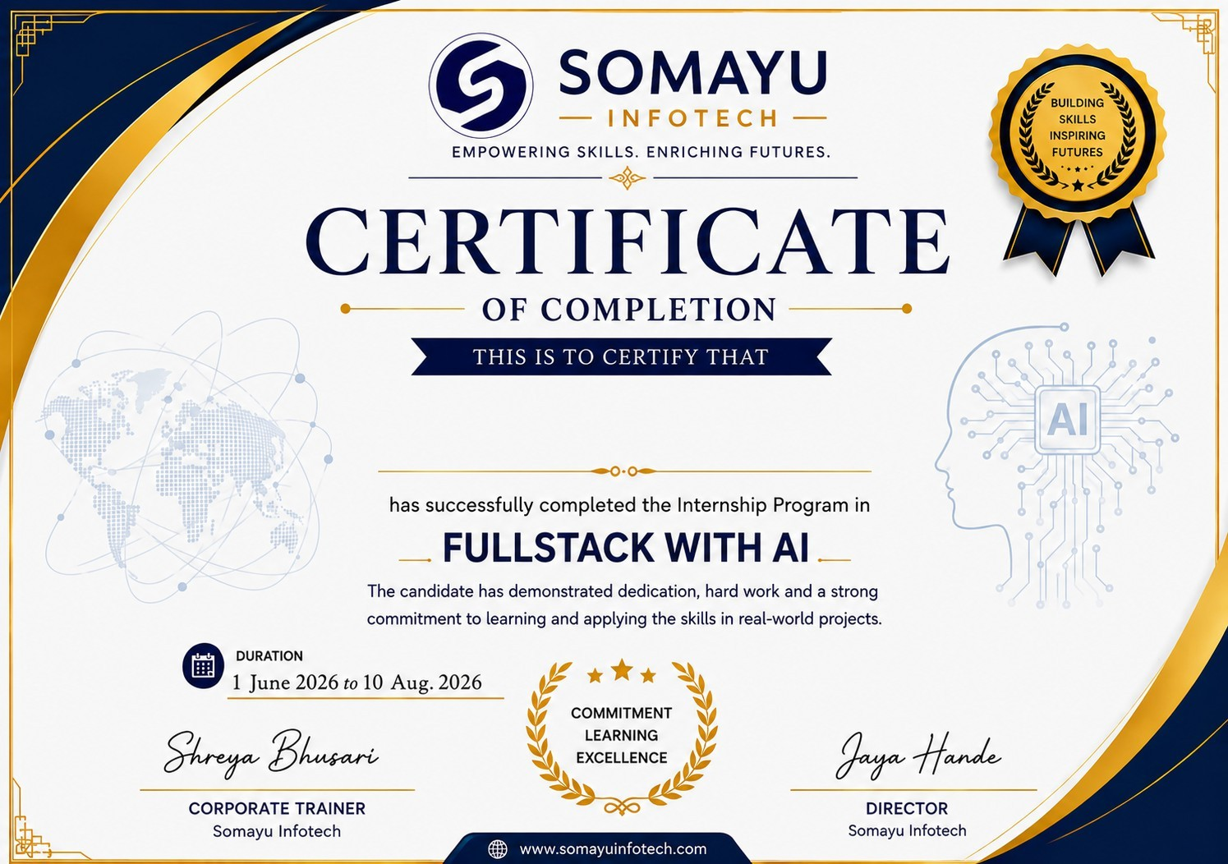
--- PROJECT 01: AMAZON : THE SHOPPING KING (E-COMMERCE WEB PLATFORM) ---
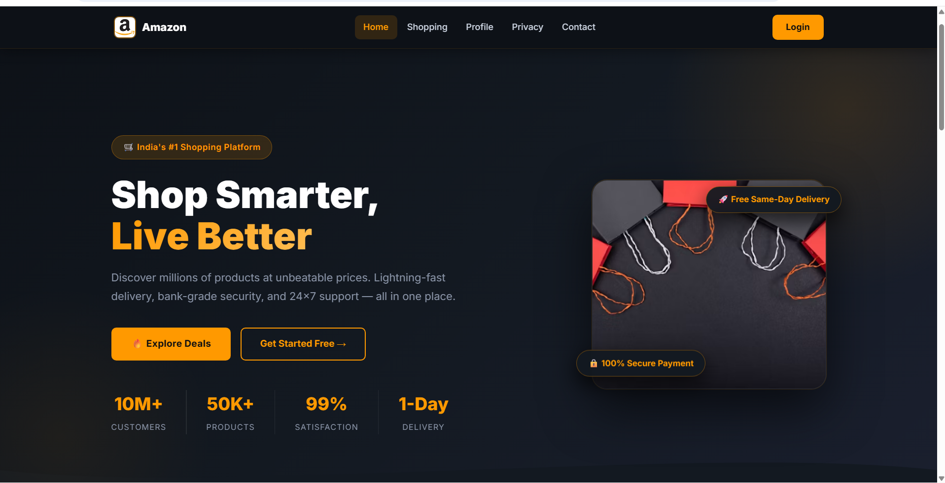
Figure 10.1: Amazon E-Commerce Storefront Homepage & UI Layout

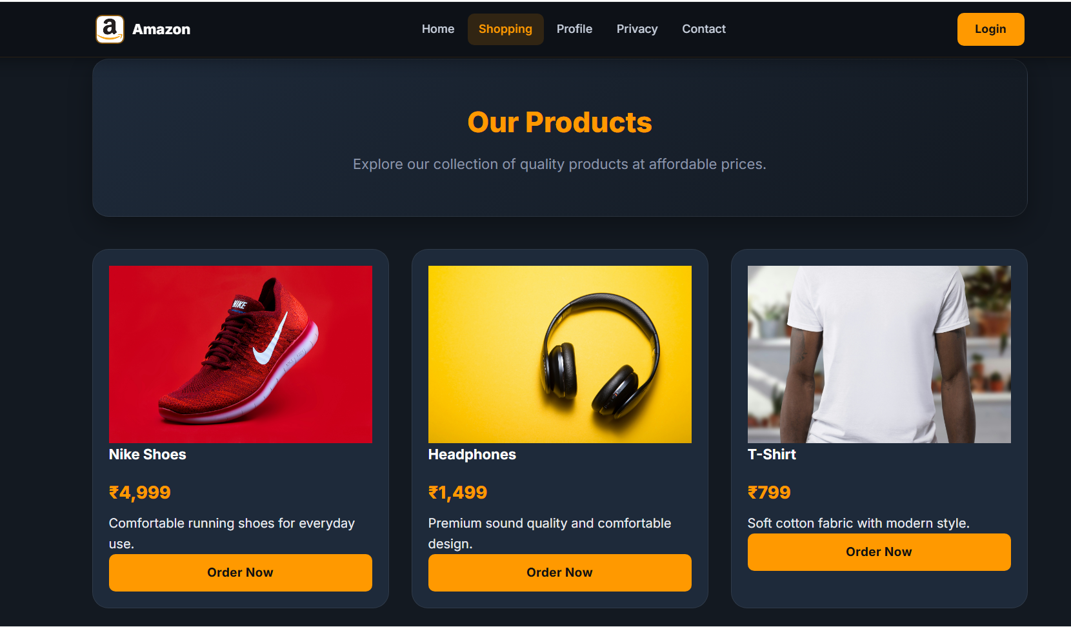
Figure 10.2: Amazon Product Shopping Catalog & Cart Management

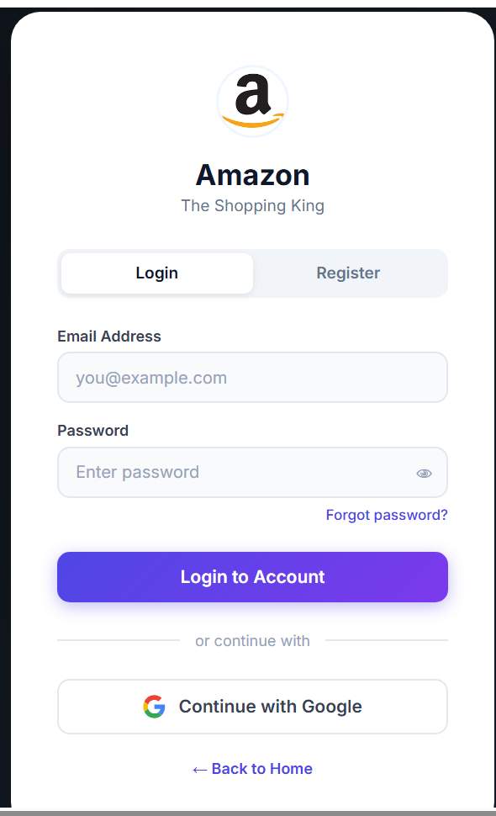
Figure 10.3: Amazon User Authentication & Login Interface

--- PROJECT 02: HOSPITAL ER DASHBOARD (POWER BI DATA ANALYTICS) ---
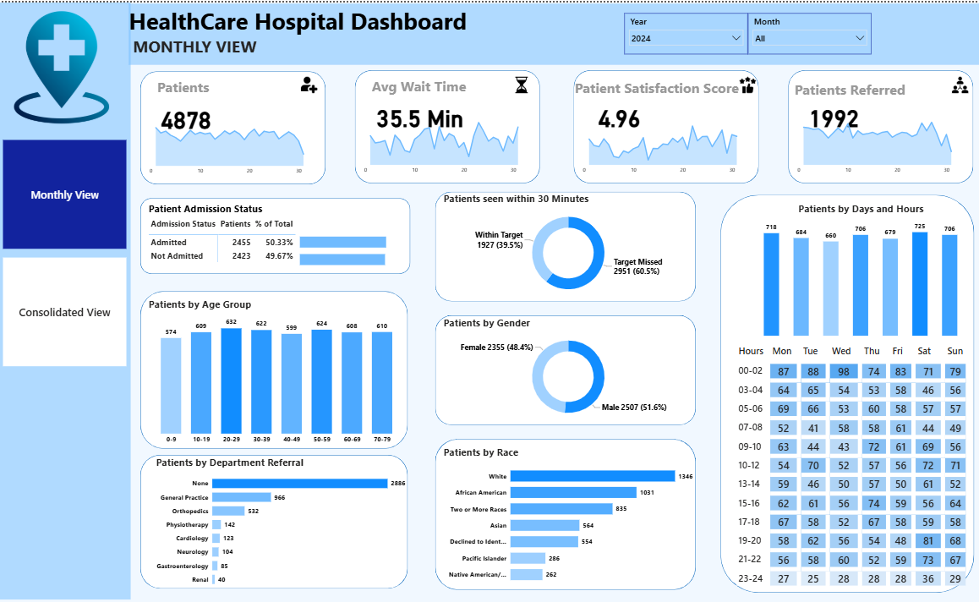
Figure 10.4: Hospital Emergency Room Monthly Analytics Dashboard

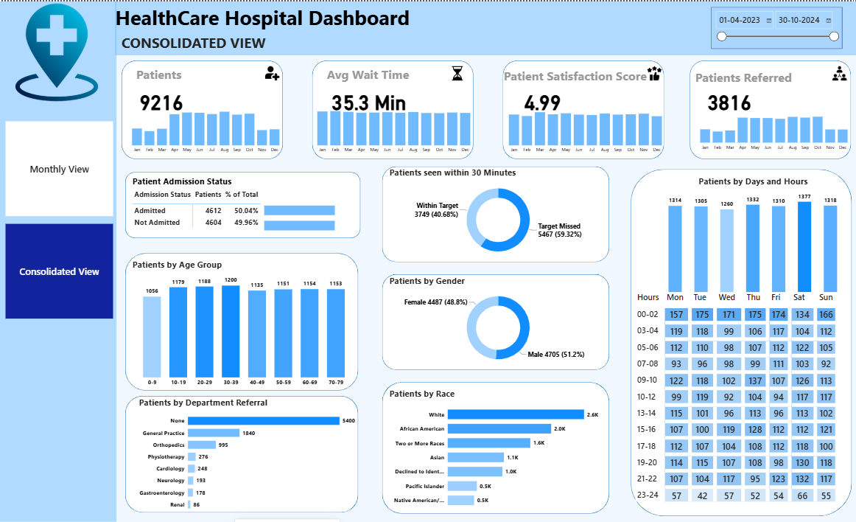
Figure 10.5: Consolidated ER Department KPIs, Patient Volume & Length of Stay Analytics

--- PROJECT 03: COLLEGE SAHAYAK (FULL-STACK WEB APPLICATION WITH AI) ---
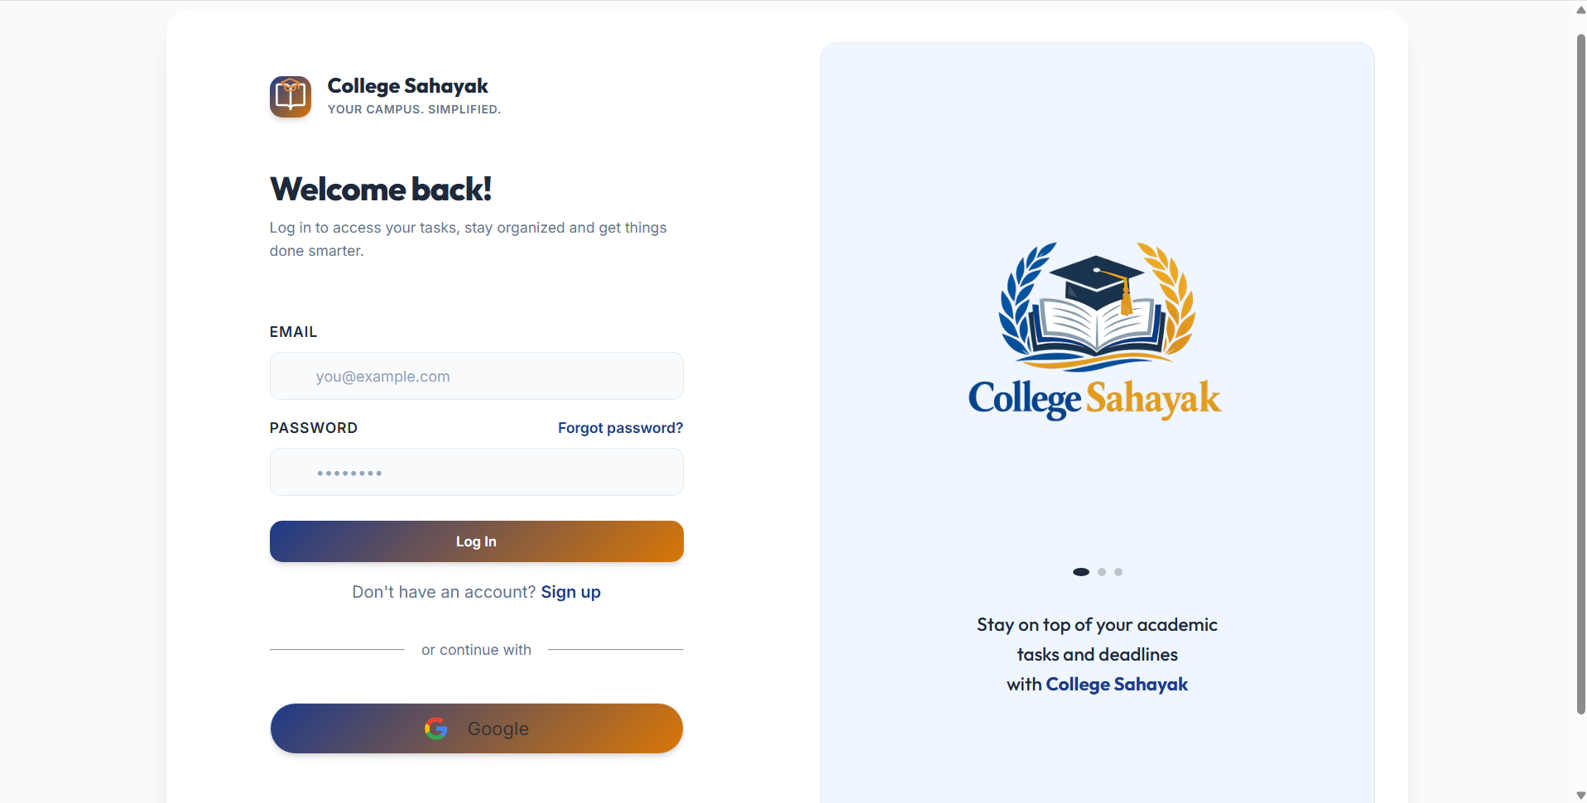
Figure 10.6: College Sahayak Secure User Login Interface

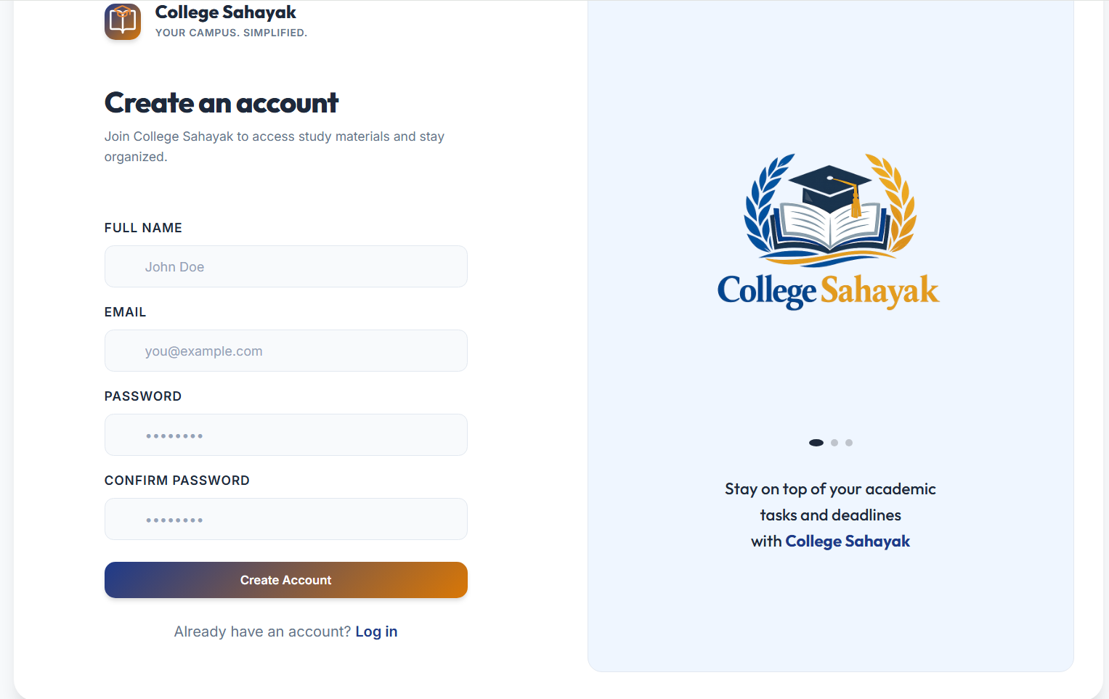
Figure 10.7: College Sahayak User Registration & Account Creation

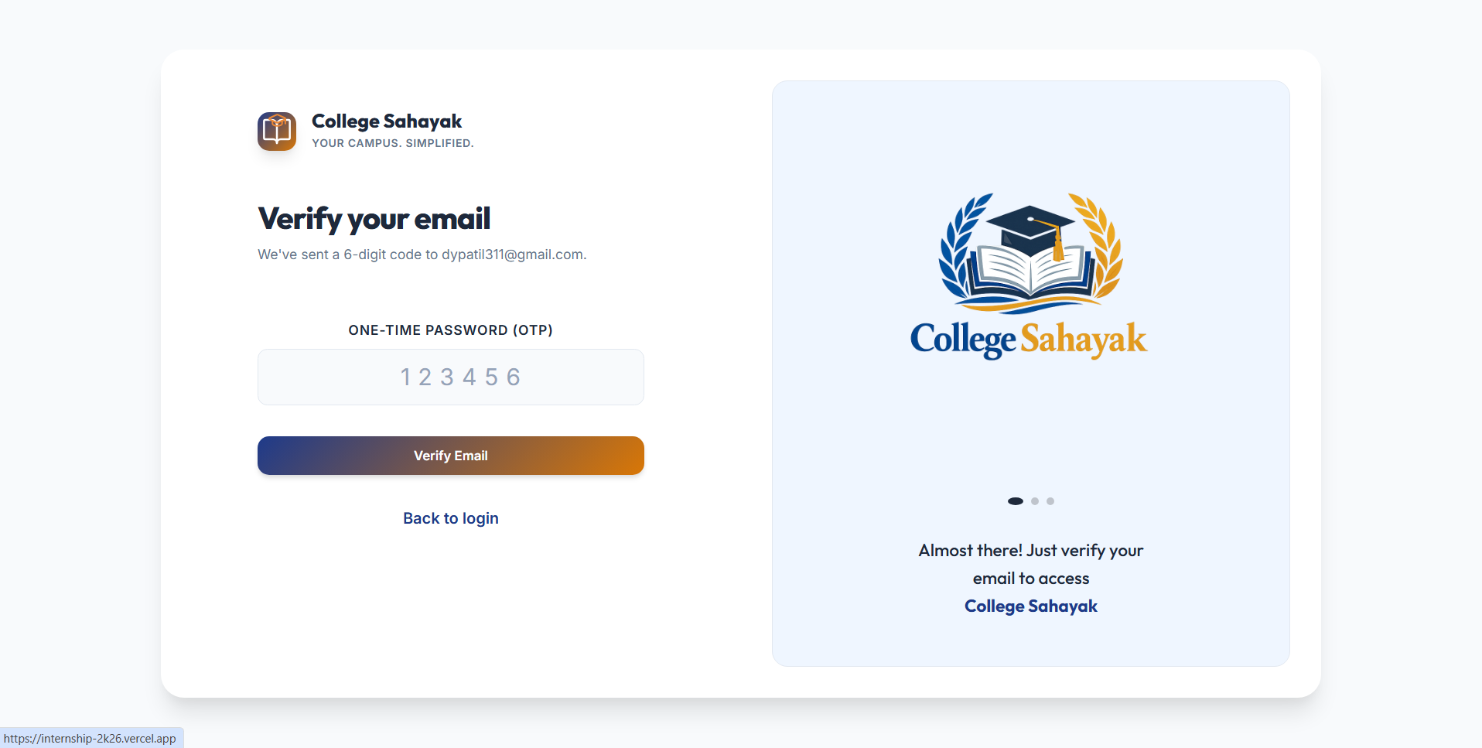
Figure 10.8: Email OTP Verification Modal

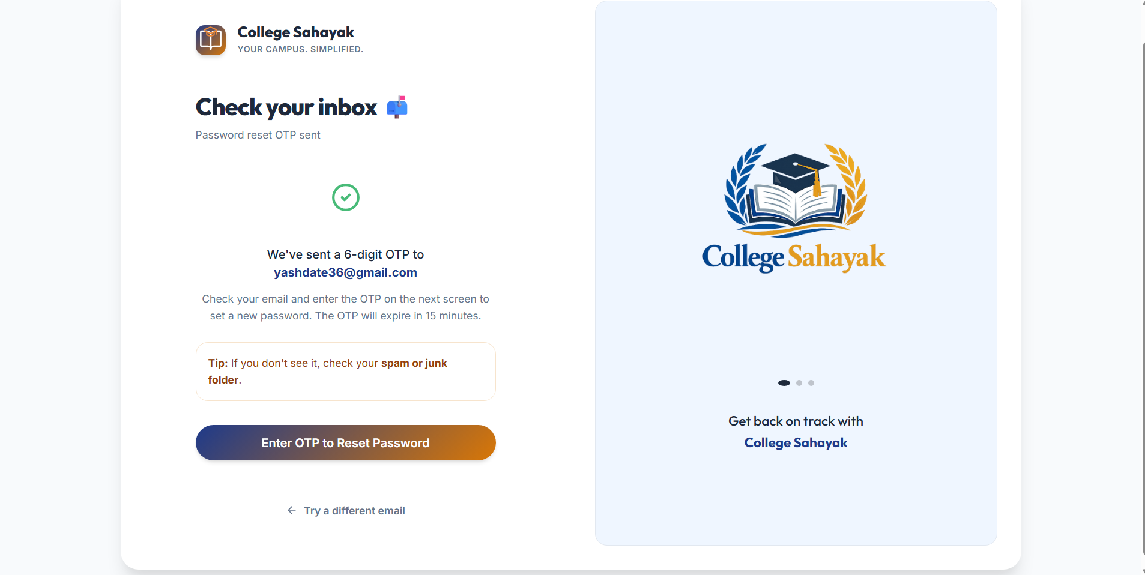
Figure 10.9: Password Reset Request Interface

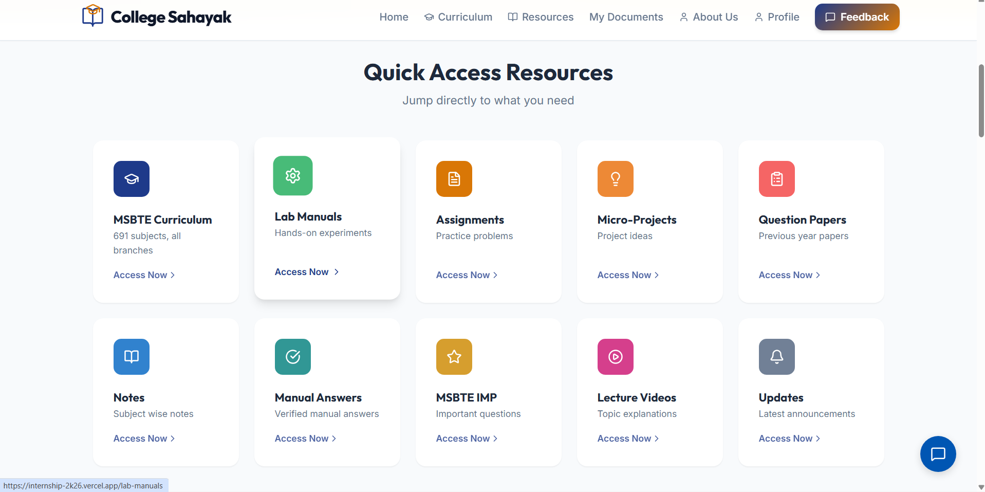
Figure 10.10: MSBTE Diploma Materials Hub Portal

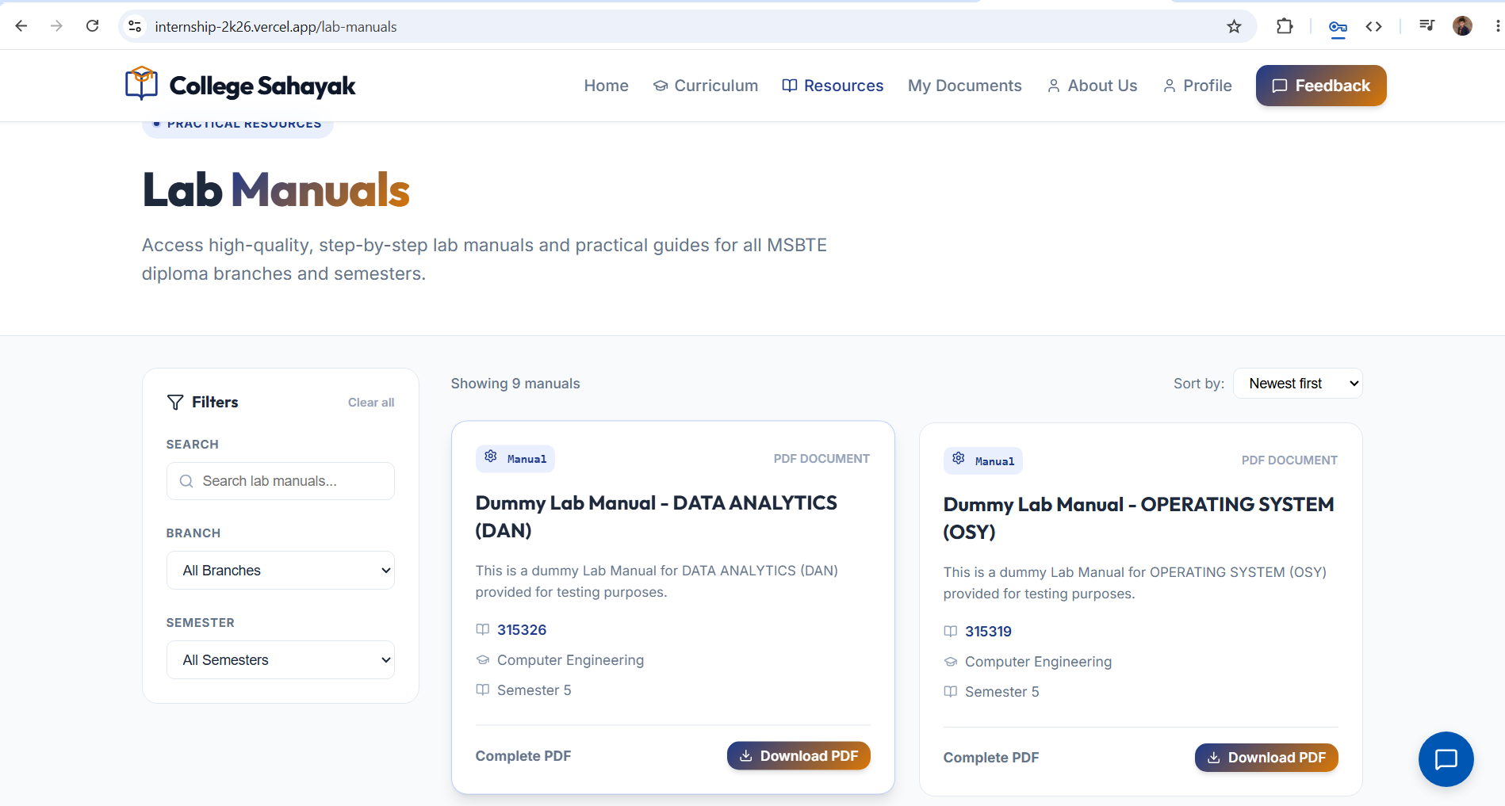
Figure 10.11: Lab Manuals & Curriculum Study Resources

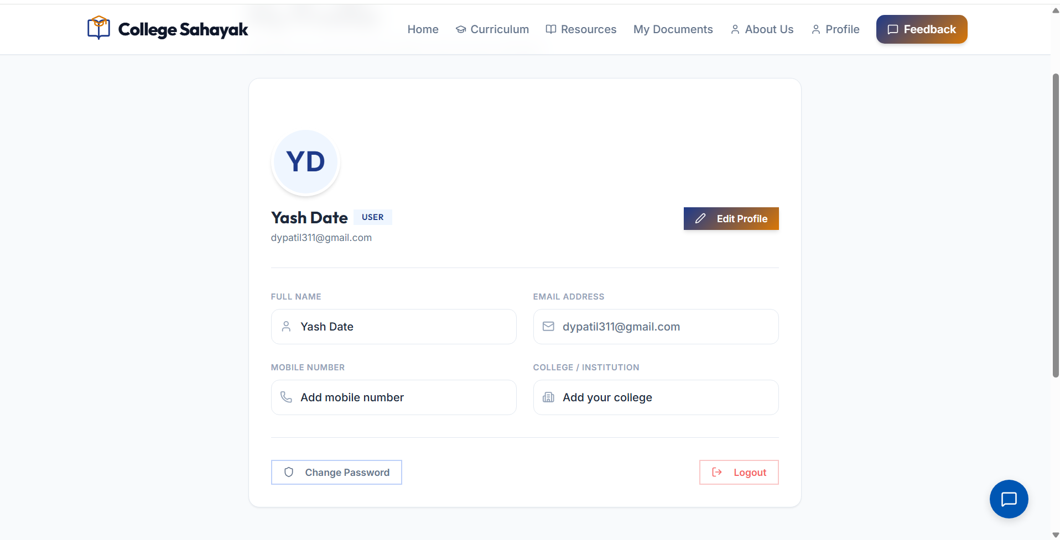
Figure 10.12: User Profile & Personal Account Settings Workspace

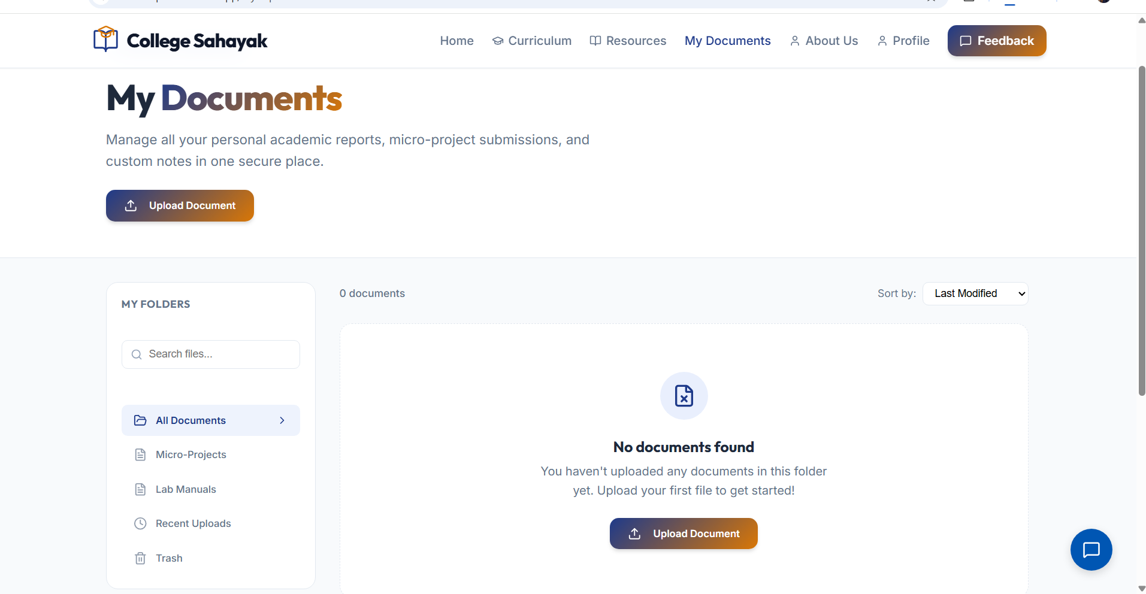
Figure 10.13: My Documents Workspace & Real-time Upload Tracking System

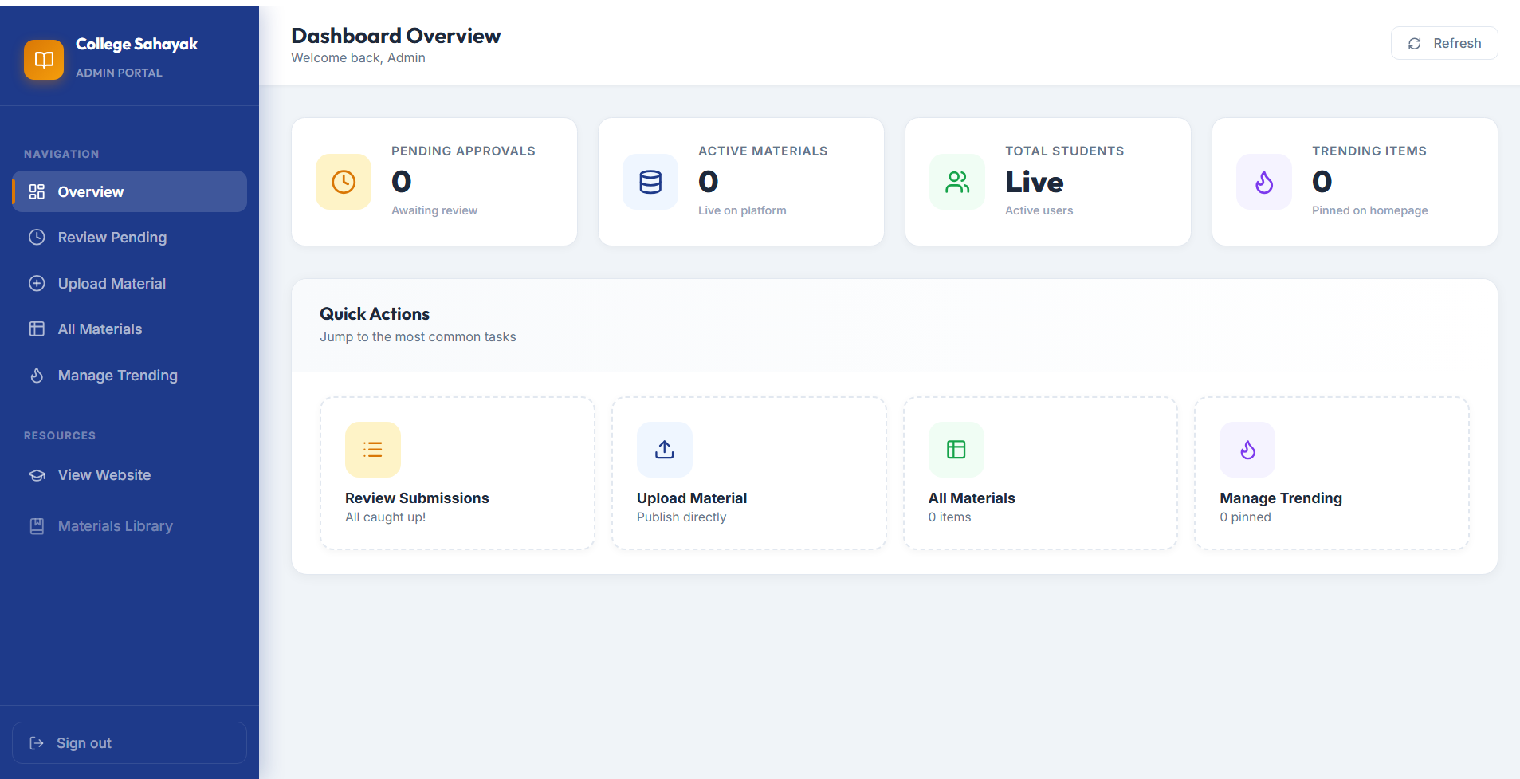
Figure 10.14: Admin Moderation Panel (Approve / Reject Student Submissions)

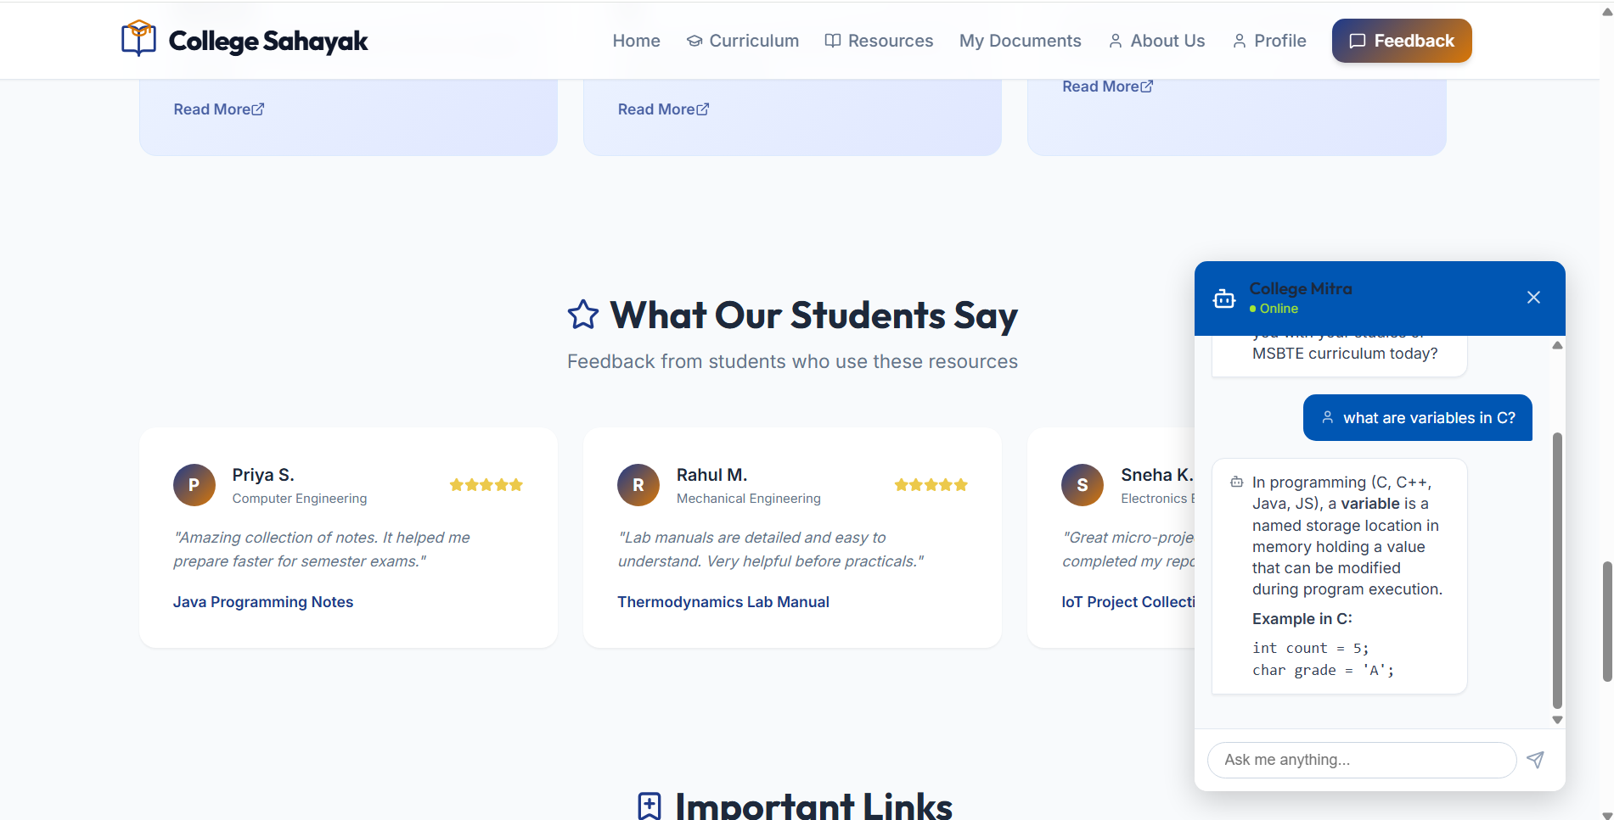
Figure 10.15: College Mitra AI Academic Chatbot Assistant (Google Gemini 2.0 Flash API)

